**Admin side**

**1. Reseller list :** No Update

**2. Commission detail:** In this section commission details form customer with the reseller will display. Fields are : INV #, SAN, Reseller name, Date, Total Invoice amount, Commission Amount.

Filter:

* Date: From & To
* SAN
* Reseller name : Name with Reseller User ID
* Commission Amount

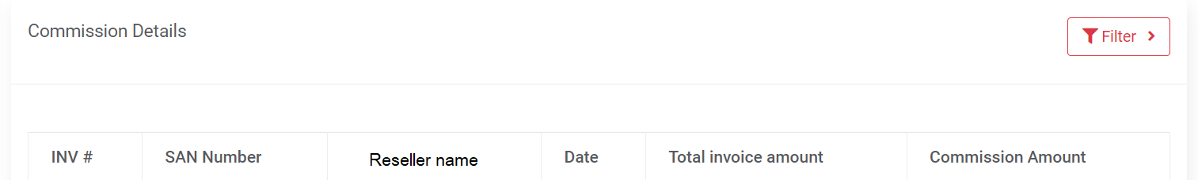

**3. Commission Summery**

* Change the name of commission details page into Commission Summery
* Add a new column of name “Payment”. Add button name “Pay” in every row

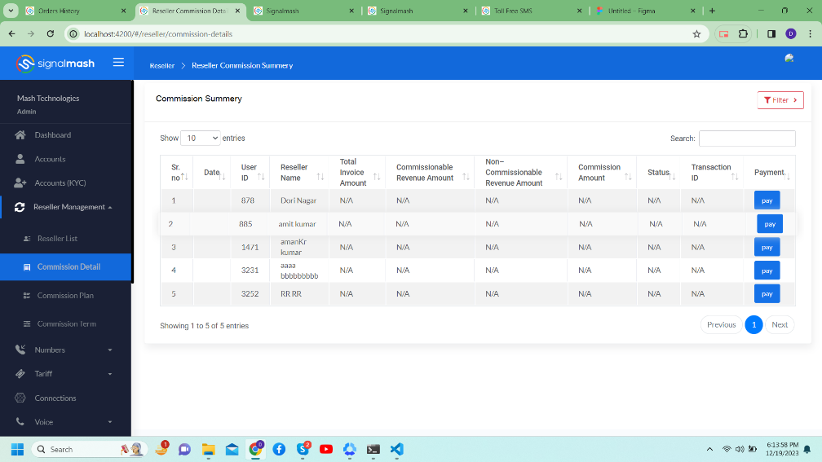

* After competing commission payment offline admin tag payment details. When admin click on the “Pay” button then “Transaction tagging” popup will open which contain Transaction ID, Amount & Comment. Commission Amount will be auto populated in the Amount section and not be editable. After submitting Pay button get disable, Status get change from Pending to Paid & transaction ID will be updated.

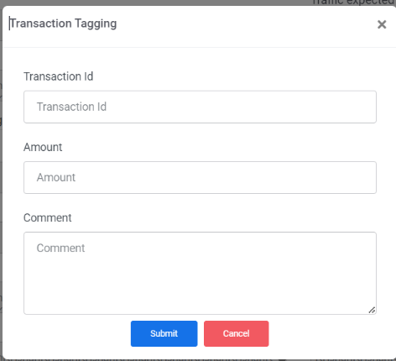

* When admin click on the Reseller commission summery row then redirected to the Commission Details page and filter will auto apply according to the particular reseller. If admin want to change the filter then it can be applicable to check other details.
* Filter:
* Reseller name- List of reseller name with Reseller User ID
* Add Status dropdown – Paid & Pending

**4. Commission plan:** No change

**5. Commission term:** No change

**Reseller side**

1. **Commission Details:** Remove “All Total Commission Dues” section from the bottom of the table.
2. **Commission Summary:**

* Add commission Summary sub module under the Commission module.
* Summary of particular reseller will display according to the month. Current month should be at the top.

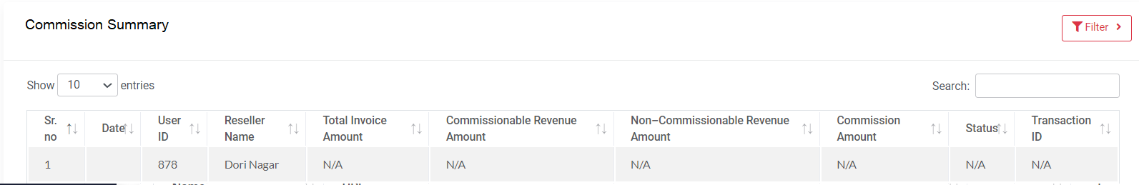

* Status “Paid” & Transaction ID will be updated on the Commission which is paid by Admin.
* If commission is not paid yet then Status will be Pending & Transaction ID is blank.
* At the bottom of the table show “All Total Commission Due” section. Total due amount will display in this section



* Filter:
* Date : From & To date
* Transaction ID
* Status dropdown: Paid & Pending

1. **Commission Plan:** 
   * When Reseller click on the Commission plan then directly commission plan display. Do not display commission plan list
   * Add “Commission plan: Plan name” at the top of the Revenue Range table.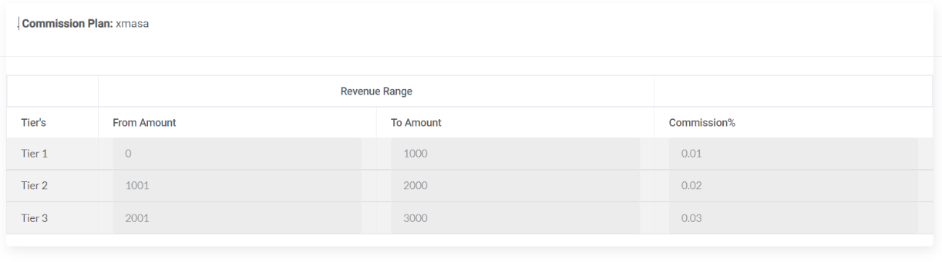
2. **Commission Term: No Change**
3. **Signup Referral Link:**

* Change “Data” column to “Created Date” column.
* Add new Column with name “Updated date” next to the Created date.
* When new link generated then Created date & Updated date should be same, but when any link update then only “Update Date” get update date.
* Whenever generated link get updated then previous link should not work. And 404 error message display in page.
* Generated & Updated link in the table is clickable. When click on the link then it open in another tab.
* Add copy option to the every link which is generated or updated.

