**Documentation for Tariff Update Phase 1**

**Feature #13077: Tariff Update & Invoice layout change to allow anniversary & billing frequency changes.**

**Admin Side:**

1. In the Add, Edit, Copy tariff need to hide Billing Type section from the Number Activation Pricing section.

**Hiding Billing Type Section**:

In the process of adding, editing, or copying a tariff, the "Billing Type" section needs to be hidden specifically from the "Number Activation Pricing" section. This ensures that users do not see or interact with the billing type options when they are dealing with number activation pricing.

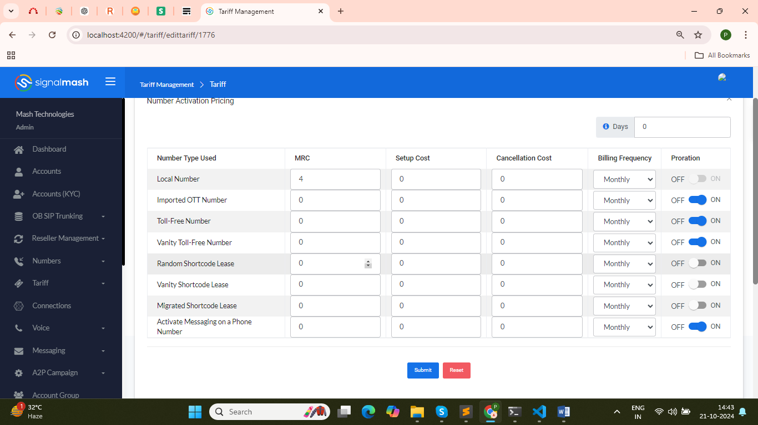

* If we remove this then it was maybe impacted on old tariff and for this value alter is also done in database.
* Without affected, so we hide this section only not change the any backend process.
* Also remove the completely dependency of billing type from the tariff.
* Change are done in add tariff component, edit-tariff component & copy-tariff component.

**Path**: angular\admin_pannel\src\app\tariff\tariff

**Path**: angular\admin_pannel\src\app\tariff\unregistered\edittariff

**Path**: angular\admin_pannel\src\app\tariff\unregistered\clonetariff

**Path**: angular\admin_pannel\src\assets\messagepricing.json

1. Billing frequency have 4 option to select i.e. Monthly, Quarterly, Half Yearly & Yearly.

* While user add new tariff, edit-tariff details & copy-tariff for any existing tariff then in billing frequency showing 4 option to selected that is., Monthly, Quarterly, Half Yearly & Yearly.

**Billing Frequency Options**:

The billing frequency will have four selectable options: Monthly, Quarterly, Half-Yearly, and Yearly. These options provide flexibility in how often the billing cycle occurs.

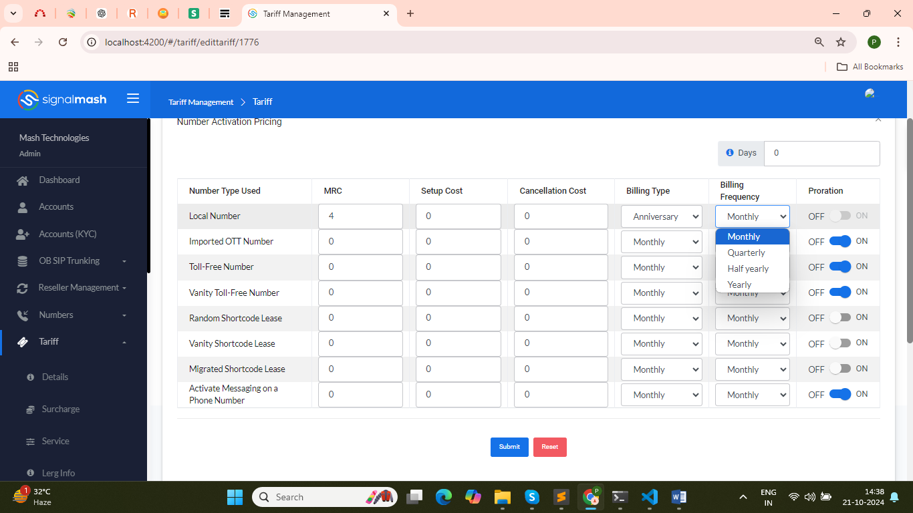

1. When Billing frequency is monthly then only proration can be ON or OFF, but for billing Frequency Quarterly, Half Yearly & Yearly proration should be OFF.

**Proration Behavior Based on Billing Frequency**:

If the billing frequency is set to Monthly, proration can either be turned ON or OFF, allowing for partial billing for the first or last billing periods. However, for the billing frequencies set to Quarterly, Half-Yearly, or Yearly, proration should automatically be set to OFF, as partial billing should not be allowed for these longer billing periods.

* In add tariff, edit-tariff & copy-tariff if user selected billing frequency monthly then proration will change able according to user decision ON or OFF.
* If billing frequency is other then monthly then proration is set OFF.
* If proration is monthly then it is showing enable state other it was showing disable.
* Previously, if billing type and billing frequency are different then proration is OFF and disable state but now there is no dependency of billing type with billing frequency.
* When Admin create a tariff and set Base rate 1$, Billing frequency is other than Monthly (Quarterly, Half Yearly & Yearly) then proration is by default OFF.

1. Change the name of MRC to the Base Rate Number Activation Pricing section.

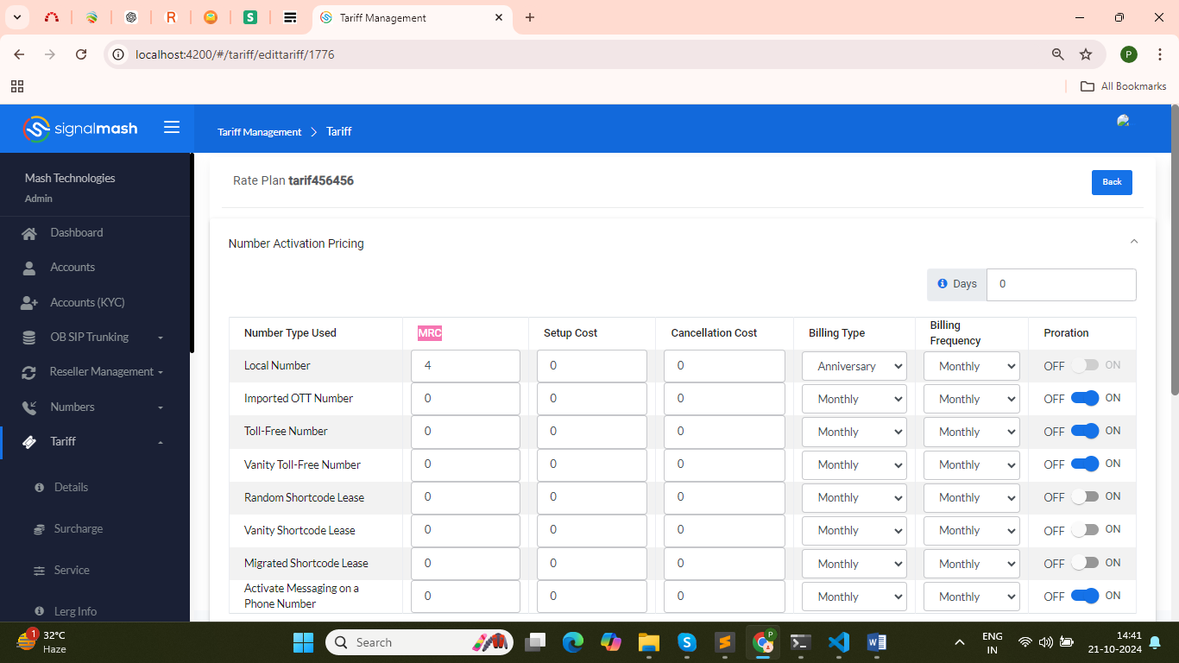

**Renaming MRC to Base Rate**:

The term "MRC" (Monthly Recurring Charge) will be changed to "Base Rate" throughout the system to make it clearer that this represents the standard monthly rate charged.

* The goal is to update the name of the field "MRC" to "Base Rate" across the relevant operations within the **Message Pricing** module, including:

**Add** operation

**Edit** operation

**Copy** operation

**Customer Rate** section

* These changes should be implemented in the **messagepricing.json** file. No impact analysis is required, and the change should not affect other parts of the system.

1. Admin enter Base rate which is a monthly rate of DID’s.

* Admin can set the value of Base rate according to monthly of DID’s while create new tariff, edit-tariff or copy-tariff in Number Activation Pricing section.

1. Once tariff is update then Update charge will apply to the all customer who has that tariff assigned.

* If admin update the any tariff rate in Number Activation Pricing section then these change are apply to that customer who has that change tariff is assigned.

**Updating Charges After Tariff Changes**:

When a tariff is updated, the system will automatically apply the updated charges to all customers who have that particular tariff assigned. This ensures consistency in billing across all customers using that tariff.

1. Under the single tariff, Billing Frequency can be differ for the Number Type.

**Variable Billing Frequency for Number Types**:

Within a single tariff, the billing frequency can differ depending on the type of number (e.g., different types of DIDs). This allows for more customized billing options based on the specific number types within the same tariff plan.

* In Number Activation Pricing section, under this of single tariff, billing frequency can be differ for the number type.
* Suppose if monthly billing frequency for local then id may be differ for shortcode or toll-free. It is not compulsory for number type have same billing frequency.

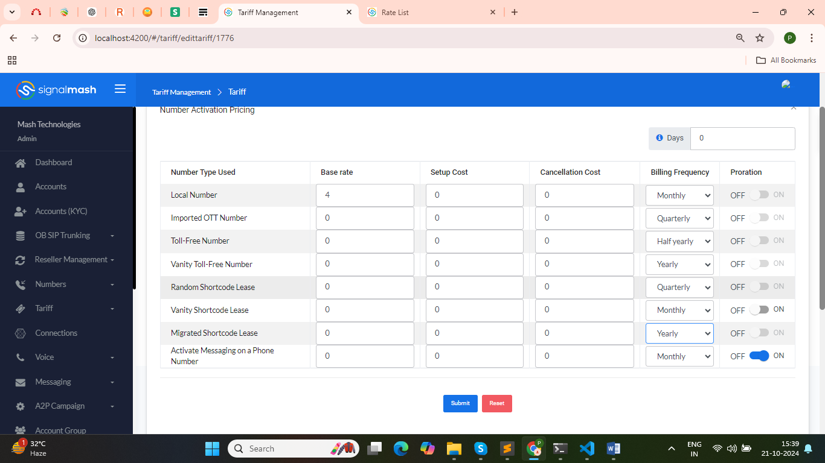

**Customer side:**

1. Billing Type is not available at the customer side on MY RATES.

* At customer side, in my rates it was showing the rate only not perform any action.
* In this also billing type and their dependency also remove or hide from Number activation Pricing.
* Change are done in customer rate (MY Rates) component.

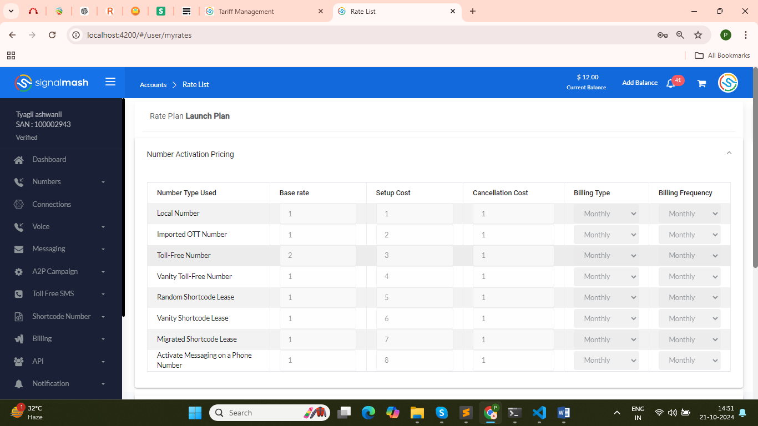

**Path**: angular\admin_pannel\src\app\usermanagement\customerrate

**Path**: angular\admin_pannel\src\assets\messagepricing.json

1. Base Rate in the Number activation Pricing should be display according to the Billing Frequency.

**When the Billing Frequency is Monthly**:

* The base rate updated by the admin is multiplied by 1. This means the base rate remains the same as what the admin has set.
* This value is what will be displayed to the customer under "MY RATES."

**When the Billing Frequency is Quarterly**:

* The base rate updated by the admin is multiplied by 3. Since quarterly refers to a 3-month period, multiplying by 3 adjusts the base rate to reflect the cost for three months.
* This adjusted rate will be shown to the customer in "MY RATES."

**When the Billing Frequency is Half-Yearly**:

* The base rate updated by the admin is multiplied by 6. Since half-yearly refers to a 6-month period, multiplying by 6 adjusts the base rate to reflect the cost for six months.
* This value will be displayed to the customer in "MY RATES."

**When the Billing Frequency is Yearly**:

* The base rate updated by the admin is multiplied by 12. As yearly billing covers a 12-month period, multiplying by 12 adjusts the base rate to reflect the cost for a full year.
* This rate will be shown to the customer in "MY RATES."

In summary, the base rate is adjusted based on the billing frequency to show the appropriate rate in "MY RATES" for customers, reflecting whether they are billed monthly, quarterly, half-yearly, or yearly.

**Example:**

1. **Monthly Billing Frequency Example**:
   * If the admin sets the base rate for a local number at **0.90** and selects the billing frequency as **monthly**, this means the rate will be multiplied by 1 (as monthly billing doesn’t change the rate).
   * **Admin Side**: The base rate remains **0.90**.
   * **Customer Side**: The base rate displayed in the "MY RATES" section will also be **0.90**.
2. **Quarterly Billing Frequency Example**:
   * If the admin sets the base rate for a local number at **0.90** and selects the billing frequency as **quarterly**, this means the rate will be multiplied by 3 (since quarterly billing covers three months).
   * **Admin Side**: The base rate remains **0.90**.
   * **Customer Side**: The base rate shown in "MY RATES" will be **2.7** (0.90 × 3).
3. **Half-Yearly Billing Frequency Example**:
   * If the admin sets the base rate for a local number at **0.90** and selects the billing frequency as **half-yearly**, this means the rate will be multiplied by 6 (since half-yearly billing covers six months).
   * **Admin Side**: The base rate remains **0.90**.
   * **Customer Side**: The base rate displayed in "MY RATES" will be **5.4** (0.90 × 6).
4. **Yearly Billing Frequency Example**:
   * If the admin sets the base rate for a local number at **0.90** and selects the billing frequency as **yearly**, this means the rate will be multiplied by 12 (as yearly billing covers twelve months).
   * **Admin Side**: The base rate remains **0.90**.
   * **Customer Side**: The base rate shown in "MY RATES" will be **10.8** (0.90 × 12).

In all cases, the base rate displayed to the customer is adjusted according to the selected billing frequency, while the admin always sees the original base rate they set (0.90 in this example).

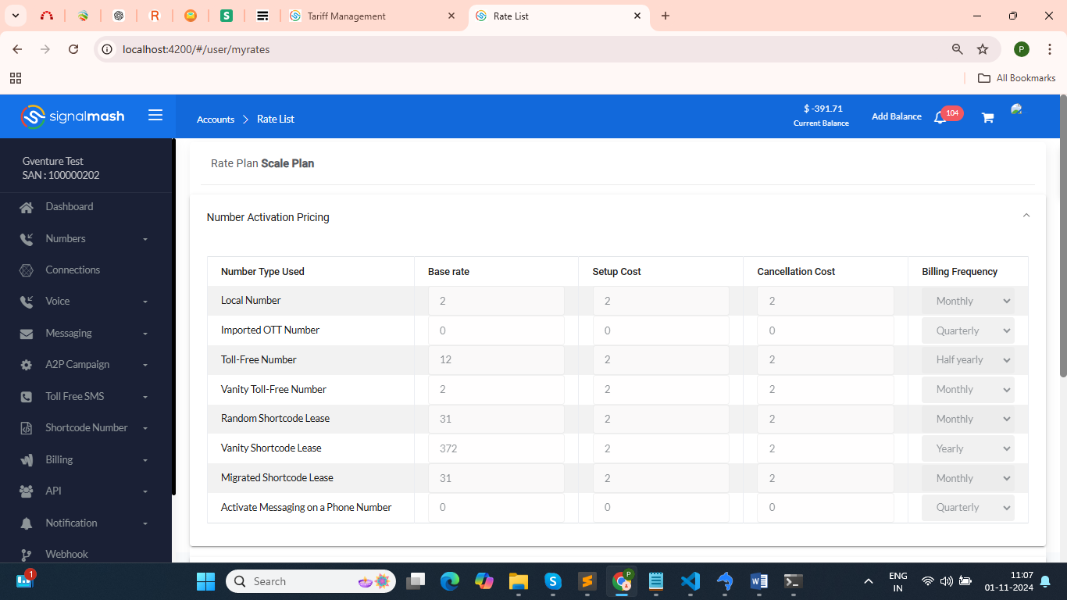

**Impact analysis after change are done in tariff.**

* 1. If admin create a tariff :
* Then if billing frequency is monthly then after customer buy did then according to billing frequency monthly proration is applied on it (meaning the charges will be calculated based on the remaining days of the month if a DID is purchased mid-month).
* But billing frequency is not monthly if it was other than monthly then proration is off so at that if customer buy did then full charges apply based on the Billing frequency.
  + - If Billing frequency is Quarterly, then charge will apply 3$
    - If Billing frequency is Half Yearly, then Charge will apply 6$
    - If Billing frequency is Yearly, then charge will apply 12$
  1. In database add a new column for showing the base rate according to billing frequency.
* Column name : final_rate
* Table name: voice_rates

          let updatedPrice = element.rate;

          switch (element.billing_frequency) {

            case '0':

              updatedPrice = element.rate * 1; // price remains the same

              break;

            case '1':

              updatedPrice = element.rate * 3; // multiply by 3

              break;

            case '2':

              updatedPrice = element.rate * 6; // multiply by 6

              break;

            case '3':

              updatedPrice = element.rate * 12; // multiply by 12

              break;

            default:

              break;

          }

* While update the tariff then manage and update the final_rate value on the based of billing frequency.
* Same condition also follow when we copy the tariff.

**Timeline**: 3 working days to complete and verify with making of documentation.