**Account cancellation**

In the Signalmash CpaaS, customer account cancellation / delete can be done by two ways.

1. Customer request for cancellation/delete
2. Admin delete customer account

**Customer request for cancellation/delete**

* Customer can request for account cancellation/delete from its profile by using “Delete Account” button. Delete account button is available in my profile section.

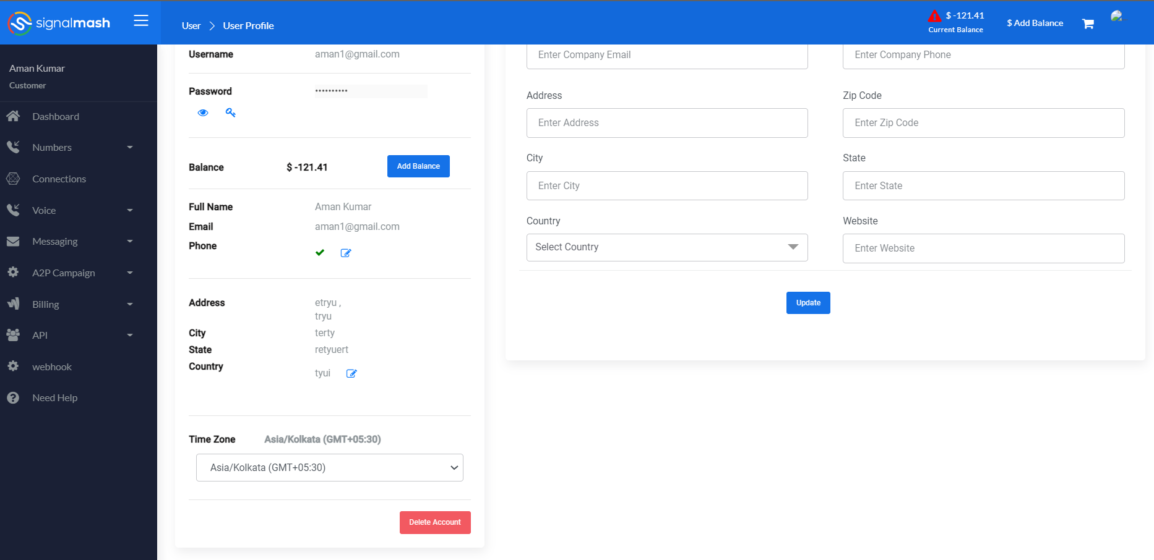

* When customer click on then “Delete Account” button then a conformation popup will open which contain Count of Active DID, Campaign, Balance, Plan Subscription & Check box for again confirmation.

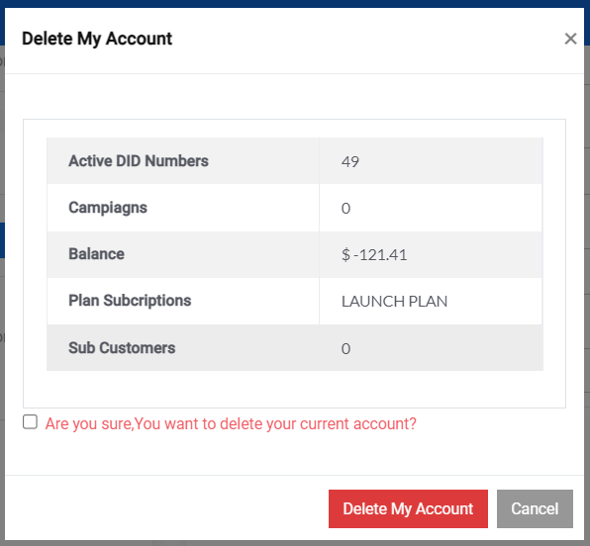

After active check box click on the “Delete My Account” button.

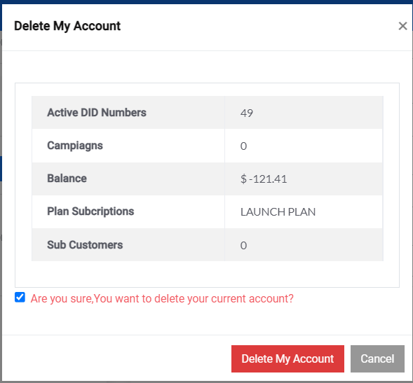

* When click on then “Delete My Account” button then wallet balance get validated.

1. If wallet is in negative then “Your balance is Low” message display



1. If Wallet balance is Zero or More then “Your account’s step one got successfully deleted” message display.

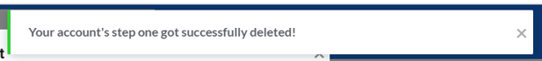

* Redirected to then delete account page, where second time confirmation required.

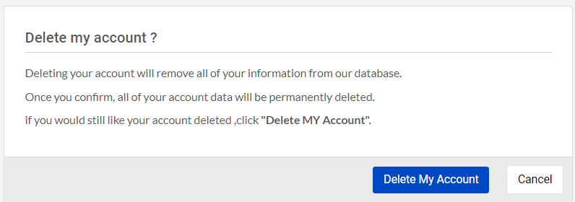

1. If customer click on then “Cancel” button then account cancellation process get cancel & customer redirected to the My Profile section.
2. If customer have DID whose End subscription date is not pass then error message display and customer move to the My profile section.

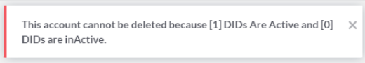

1. If customer click on the “Delete My Account” then message display “You have done Your Account Deleted process. Thank You!” then customer redirected to then Signup page.



* After completing the delete account process from customer side then in the Account section of Admin side, customer details will display in then “Pending to Release”.

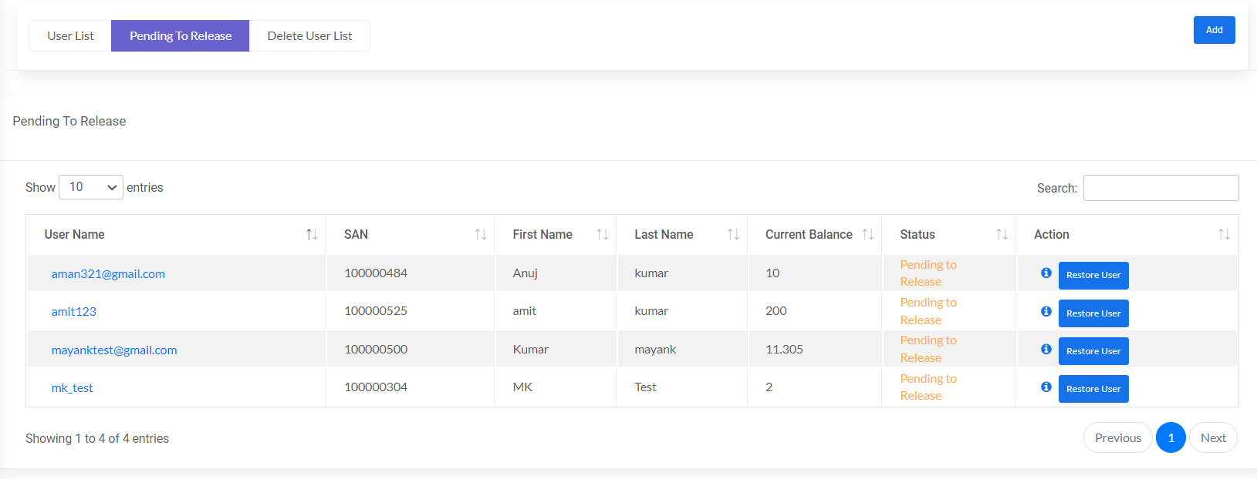

**In this condition**

1. Connection get Disable ( Customer & Sub Customer)
   * + Inbound 🡪isDeleted🡪1
     + Outbound 🡪isDeleted🡪1
     + Endpoint 🡪isDeleted🡪1
2. API key (Customer & Sub customer) 🡪 isDeleted🡪1
3. Session (Customer & Sub customer) 🡪 isDeleted🡪1
4. Status of customer, is_deleted 🡪1

* By clicking on the review account from action. Account review popup will open.



* After check “Are you sure you want to permanently remove this account?” click on the “Delete Account” button.

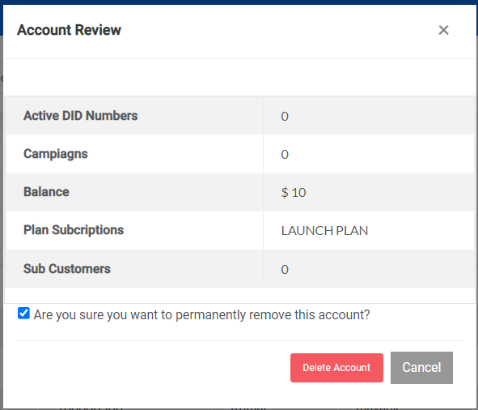

* “You have successfully deleted this account” message display



* Customer account permanently get deleted & account details move from “Pending to release” to “Deleted User List”.

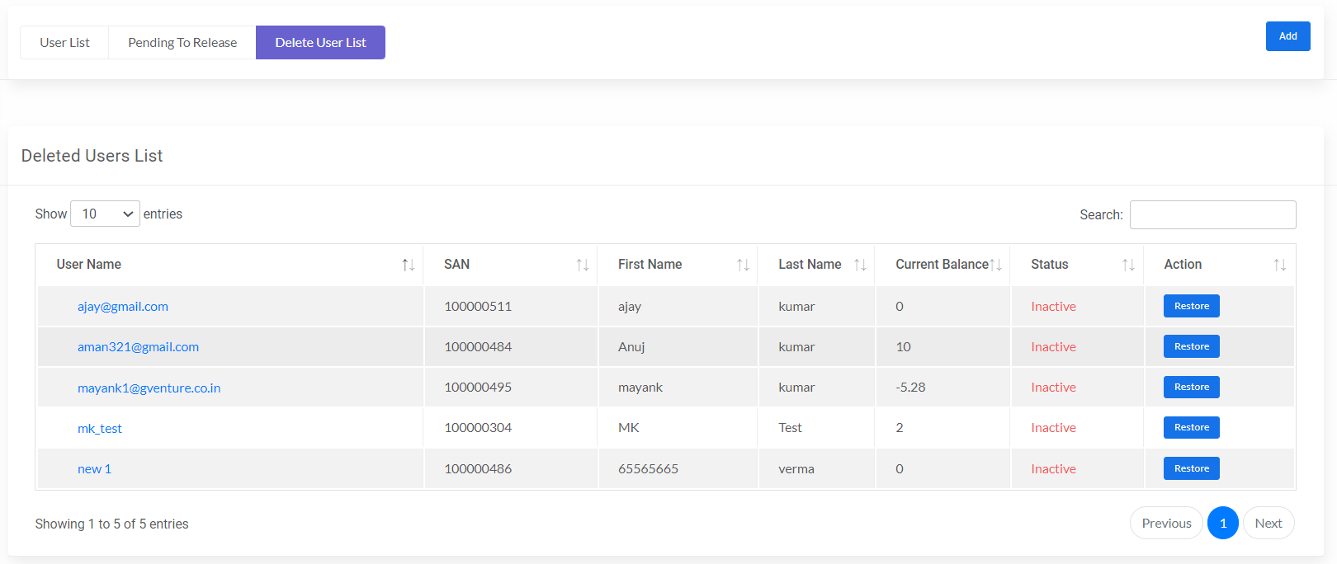

* After permanently delete of account then status

**In this condition**

1. Connection get Disable (Customer & Sub Customer),
   * Inbound 🡪isDeleted🡪2
   * Outbound 🡪isDeleted🡪2
   * Endpoint 🡪isDeleted🡪2
2. Status of customer, is_deleted 🡪2
3. Status of DID, disconnect_did_status 🡪2
4. Campaign (release), deleted 🡪2
5. Brand (release), deleted🡪2

**Restore Account**

* A **Restore Account** functionality is provided to the admin. In then Pending to release & Delete User list page “Restore” button is provided in the action section. Admin can restore customer account at any stage (Pending to release & Deleted user list)

Pending to Release

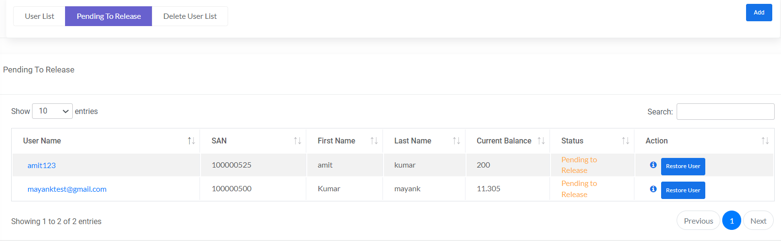

Deleted User list

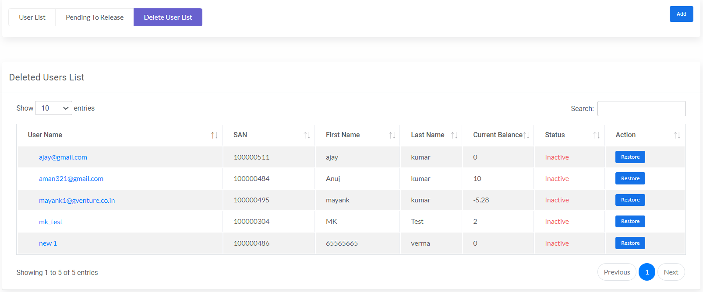

* When admin click on then “Restore” button from action section of Delete User list

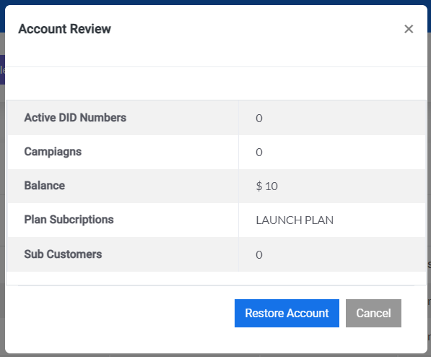

* When click on then “Restore Account” button then confirmation popup will open.

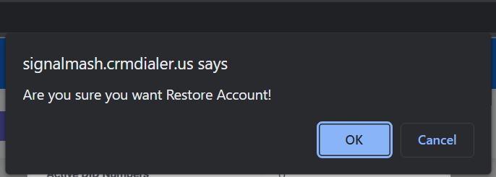

* Click on the OK button then “Customer account restore successfully” message display.



* Restore Account will move to then “Pending to release” section

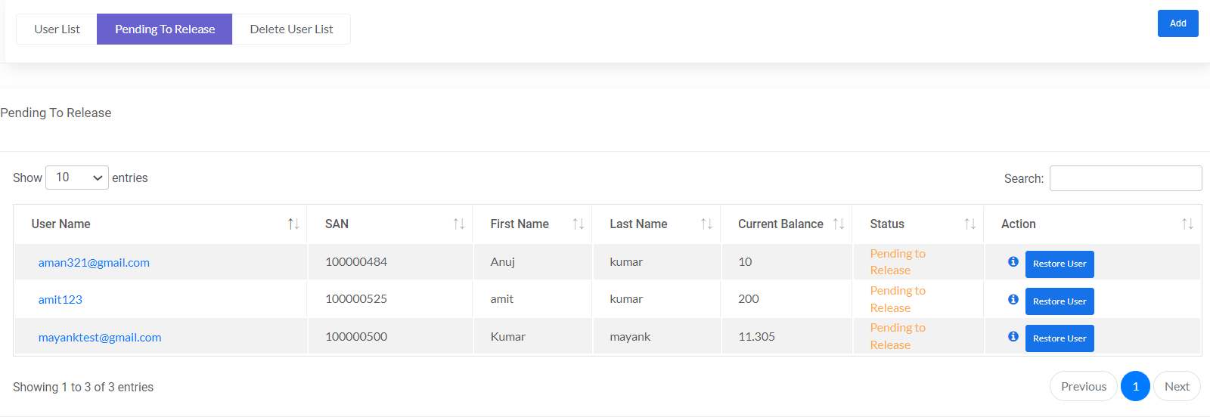

**In this condition**

1. Connection get Disable ( Customer & Sub Customer)
   * + Inbound 🡪isDeleted🡪1
     + Outbound 🡪isDeleted🡪1
     + Endpoint 🡪isDeleted🡪1
2. Status of customer, is_deleted 🡪1

* Click on the “Restore user” button from then Pending to release section then Conformation popup will display.



* Click on the OK button then “Customer account restore successfully” message display.



* After restoring user, details of user will display in the User List.

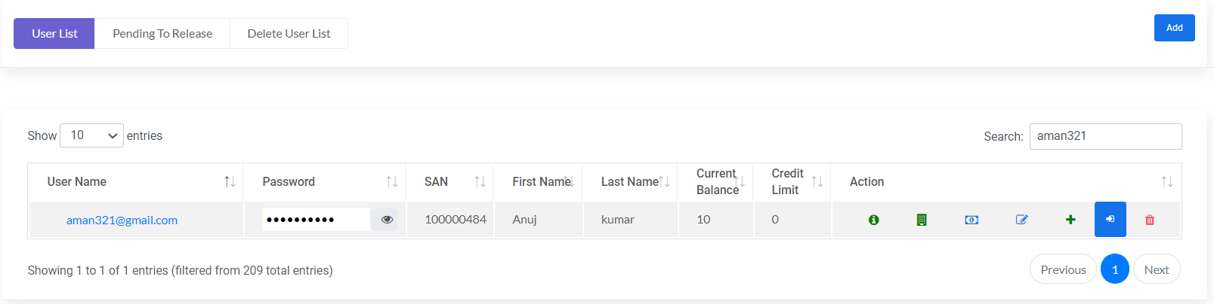

**In this condition**

1. Connection get Disable (Customer & Sub Customer)
   * + Inbound 🡪isDeleted🡪0
     + Outbound 🡪isDeleted🡪0
     + Endpoint 🡪isDeleted🡪0
2. Status of customer, is_deleted 🡪0

**Admin delete customer account**

* Admin can delete customer account from its panel by using “Delete” icon in User List. When admin delete customer account then two condition not checked and forcefully delete account:
* Negative wallet
* Active DID (End subscription data not pass)

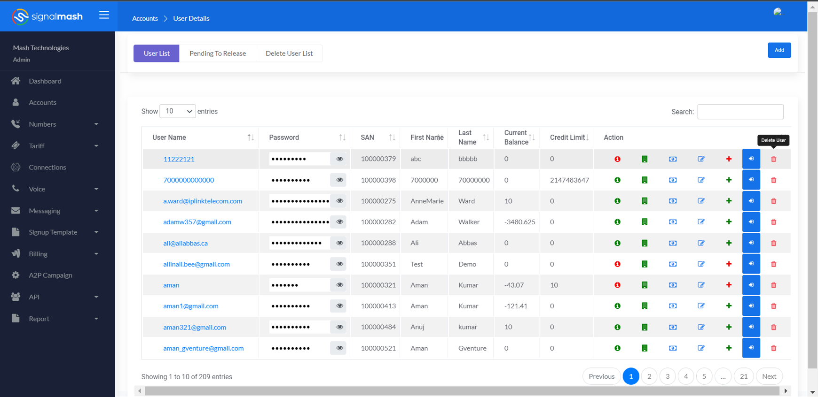

* When admin click on the delete icon then Account review page will open with details.

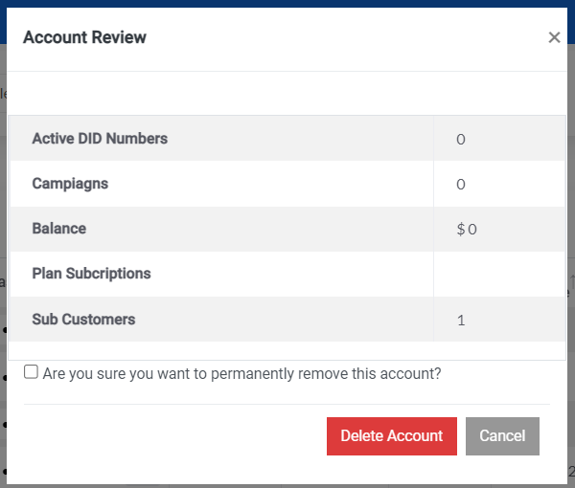

* After active check box click on the “Delete My Account” button. Then “You have successfully deleted this account!” message display.



* There is two different process follows:

1. If Onboarding is not completed then deleted customer will directly move from User list to Deleted User list.

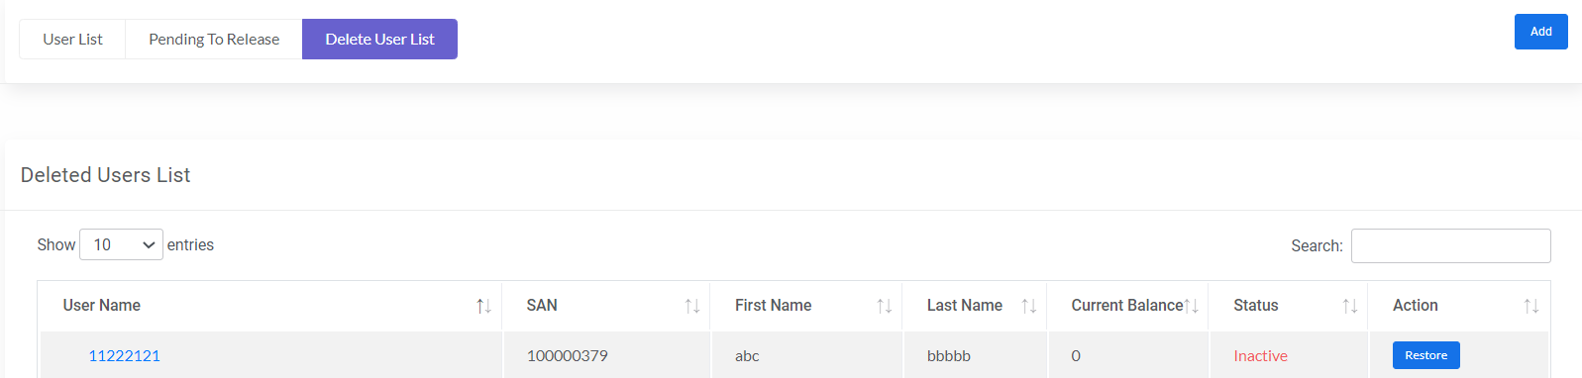

**In this condition**

Status of customer, is_deleted 🡪2

1. If Onboarding is completed then deleted customer will move from User list to Pending to release.

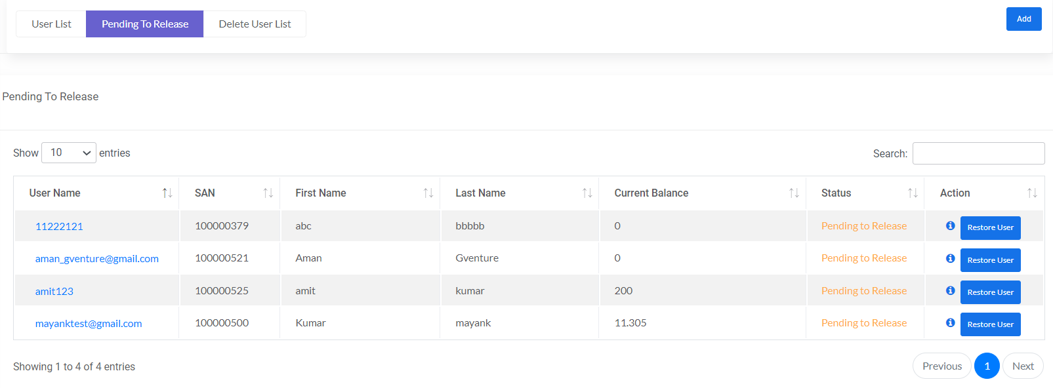

**In this condition**

1. Connection get Disable ( Customer & Sub Customer)
   * + Inbound 🡪isDeleted🡪1
     + Outbound 🡪isDeleted🡪1
     + Endpoint 🡪isDeleted🡪1
2. API key (Customer & Sub customer) 🡪 isDeleted🡪1
3. Session (Customer & Sub customer) 🡪 isDeleted🡪1
4. Status of customer, is_deleted 🡪1

When admin delete customer from Pending To Release then user permanently deleted & move to Deleted User List.

**In this condition**

1. Connection get Disable (Customer & Sub Customer),
   * Inbound 🡪isDeleted🡪2
   * Outbound 🡪isDeleted🡪2
   * Endpoint 🡪isDeleted🡪2
2. Status of customer, is_deleted 🡪2
3. Status of DID, disconnect_did_status 🡪2
4. Campaign (release), deleted 🡪2
5. Brand (release), deleted🡪2