**Brand**

1. **Brand Table:** Brand Suspended column was added to the table. Brand suspended column contains 3 dots when you click on it then a list of carriers open.

Before clicking on the 3 dots

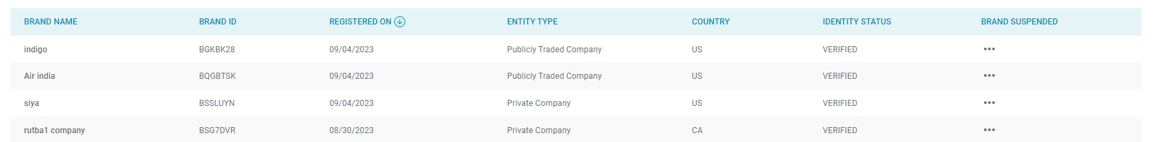

After clicking on 3 dots

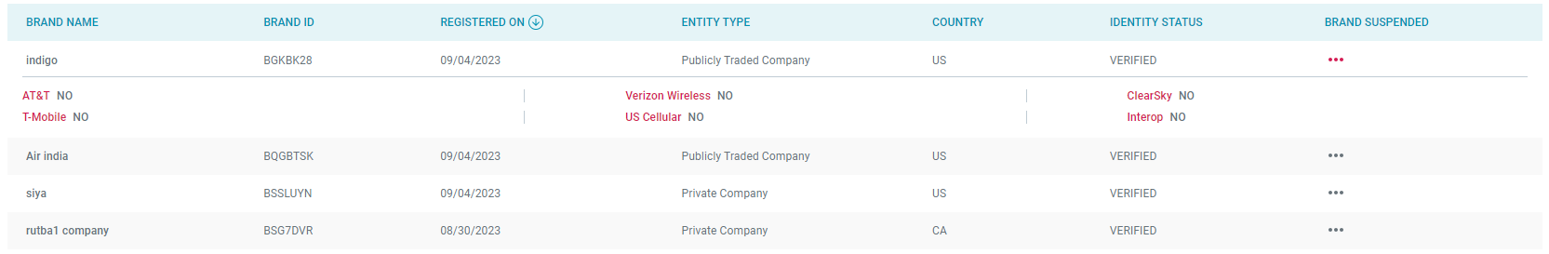

1. **Brand Details**
2. **Request Appeal Button:** New Request Appeal button added in the brand details page and Appeal history table. The Appeal request will apply only with the brand status is UNVERIFIED.

* If apply with the VERIFIED brand

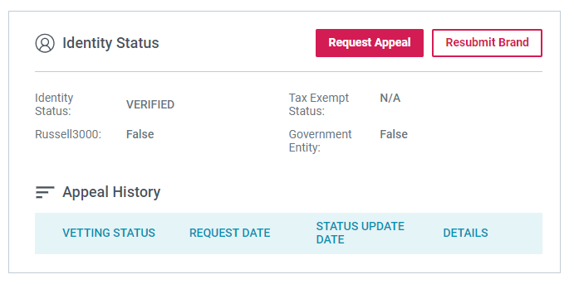

When click on the Request appeal button the Identity Appeal Request section opens with details

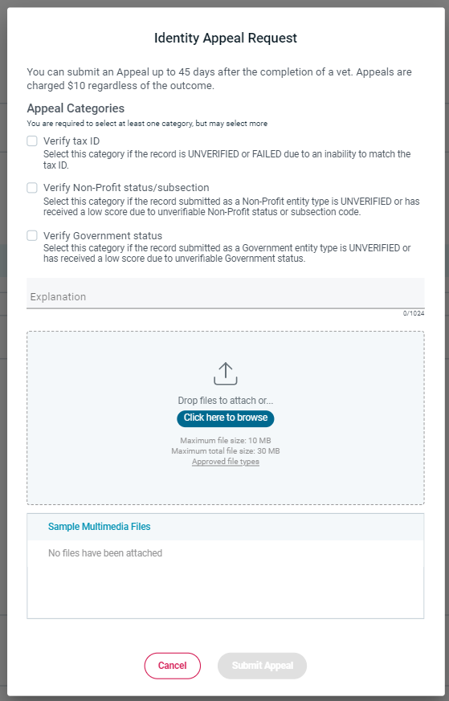

After filling in details when submitting then popup opens for confirmation

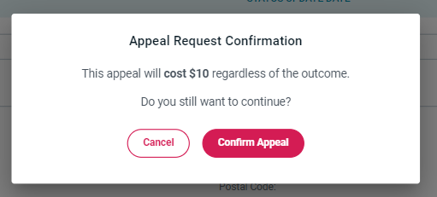

After confirmation then error message display

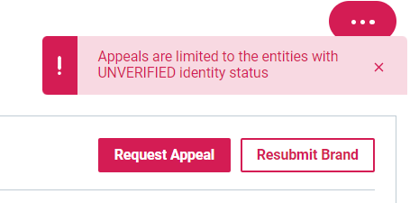

* If applied with an UNVERIFIED brand

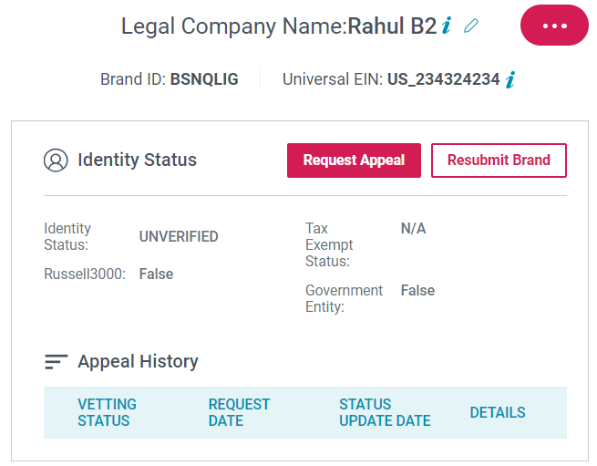

When clicking on the Request appeal button the Identity Appeal Request popup opens, fill in the details & submit, then the popup opens for confirmation. After confirming the request submitted successfully and details are displayed in the Appeal history table. Until the vetting status is pending the Identity status is also UNVERIFIED.

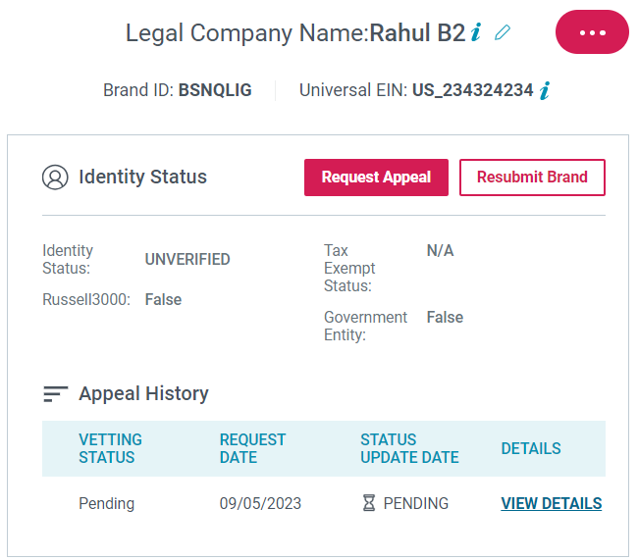

When vetting status is completed then Identity status becomes VERIFIED.

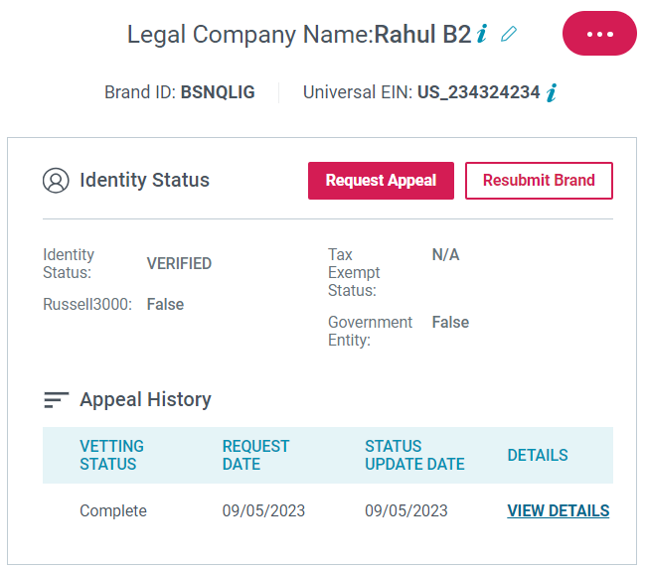

The view details link shows the details of the Identity Appeal request

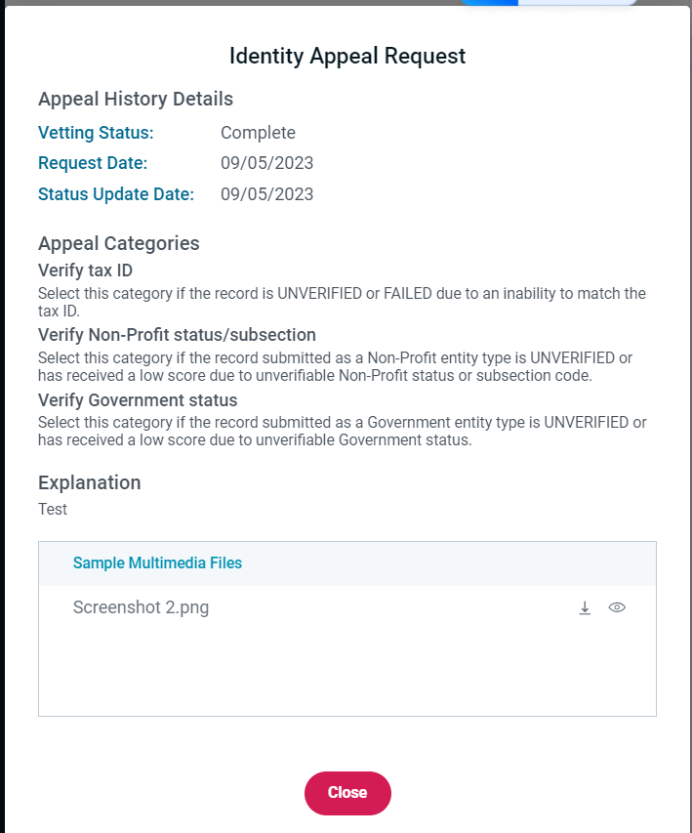

1. **Edit Company Details:** Contact details & Brand relationships are merge with company details. Then editing of contact details & brand relationships will be done by editing company details only.

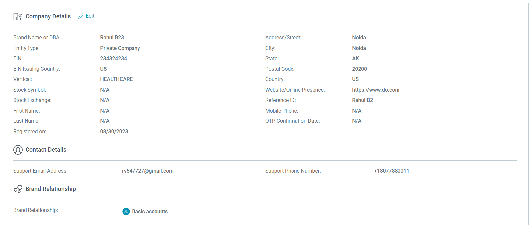

1. **Apply Vetting:** Update in the apply vetting. Comparison between current vetting in signalmash and updated vetting in CSP

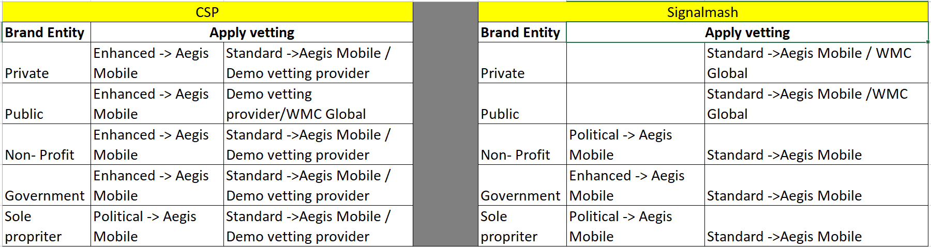

1. **Import Vetting:** Update Import Vetting. Comparison between current vetting in signalmash and updated vetting in CSP

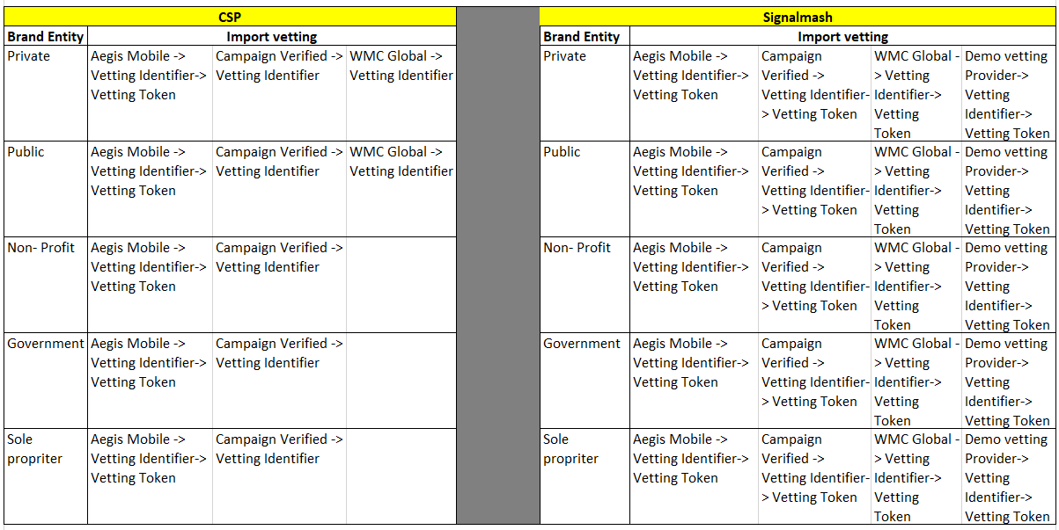

**Campaign**

1. **Campaign details:** Status & Elect DCA column added in the carrier status when we open a Campaign

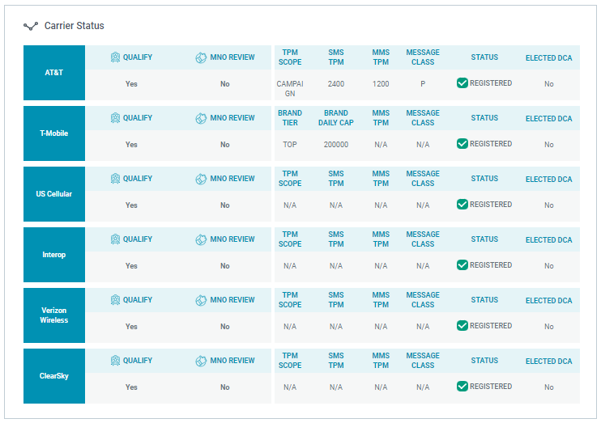

1. **Campaign creation: The other Responsible Parties section is available when creating a new campaign and it is mandatory. It provides an option to select a connectivity partner & option to select a reseller if involved.**