**Appeal Request Doc**

**Appeal can be done from 2 section**

1. To appeal an Identity status user have to click on the “Request Appeal” button at the Appeal section above the appeal history. For Appeal need to provide additional information / document regarding brand and follow instruction.



Appeal feature is only support for Aegis Standard vets.

1. If a Standard vet failed but customer are certain that the information provided is 100% accurate or believe there is a error in the Standard vet score that was returned by the brand then also Appeal can be done.

Appeal also can be done from “Action” menu in the vetting details.

1. If failed/pending/ low score for Vetting Type Standard & Vetting partner Aegis then Appeal can be done

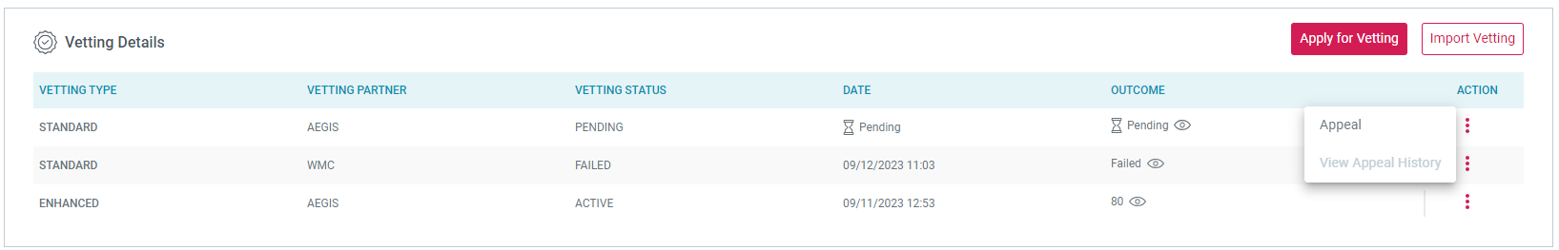

1. If Vetting type is other than STANDARD & Vetting partner is other than AEGIS, then apply for Appeal gives an message to email at appeals@aegismobile.com

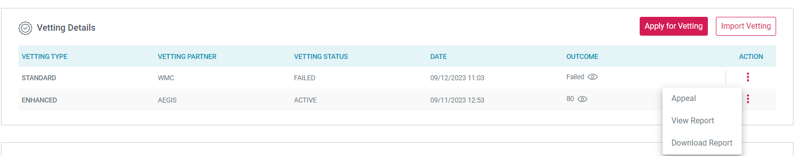

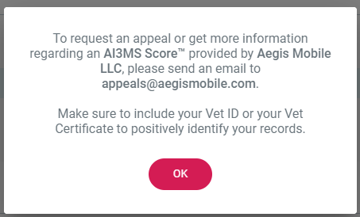

1. If Vetting Type is STANDARD but vetting partner is other than AEGIS, then apply for Appeal gives an message to email at appeals@aegismobile.com

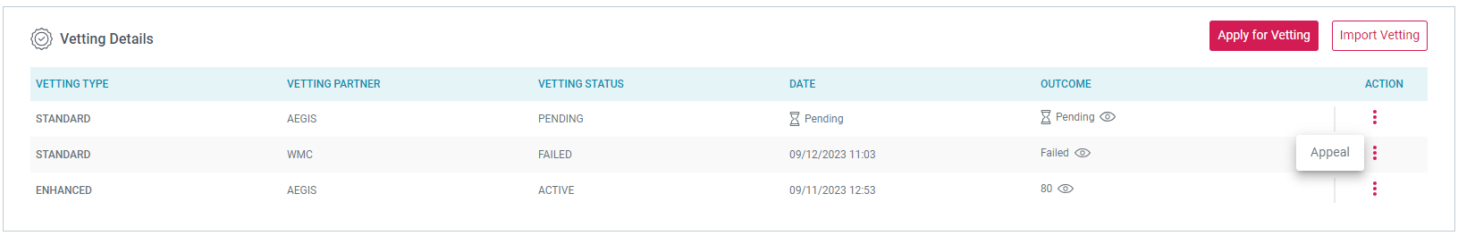

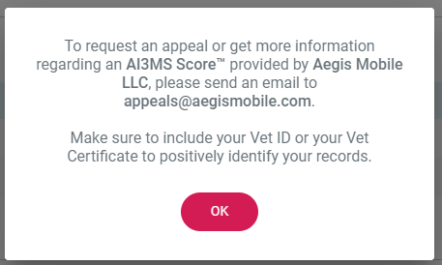

**To apply for Appeal need to follow requirement**

* Appeals are allowed for vet created within 45 days. After the 45days Appeal are not allowed. When try then error message display



* Appeal for Identity status UNVERIFIED only.
  + - If we try to appeal for VERIFIED or VETTED VERIFIED then error message display “Appeals are limited to the entities with UNVERIFIED identity status”



* + - For SELF DECLEAR(SOLE PROPROTER) appeal option is not available
* Appeal are only allowed for the latest vet
* Appeal are only allowed on the Standard Vet in the final status (Complete/ failed), If appeal for Standard Vet final status is Pending then error message display “Appeals are limited to only the ACTIVE/ FAILED vetting records”

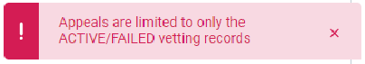

* + Each appeal charges $10 fee regardless of the outcome of the appeal
  + Once appeal submitted, then further update to the brand is accepted
  + Once appeal submitted, no further update to the appeal is accepted.
  + Re-appeal on the vet only after previous appeal completion.
  + Max 10 file can be attached for each appeal
  + Total maximum size limit for individual appeal is 30MB
  + Individual files size should be max 10MB
  + File types allowed to be attached with appeal requests: .jpg, .jpeg, .png, .bmp, .raw, .tiff, .pdf, .docx, .htm, .odt, .rtf, .txt, .xml

**Identity Appeal Request**

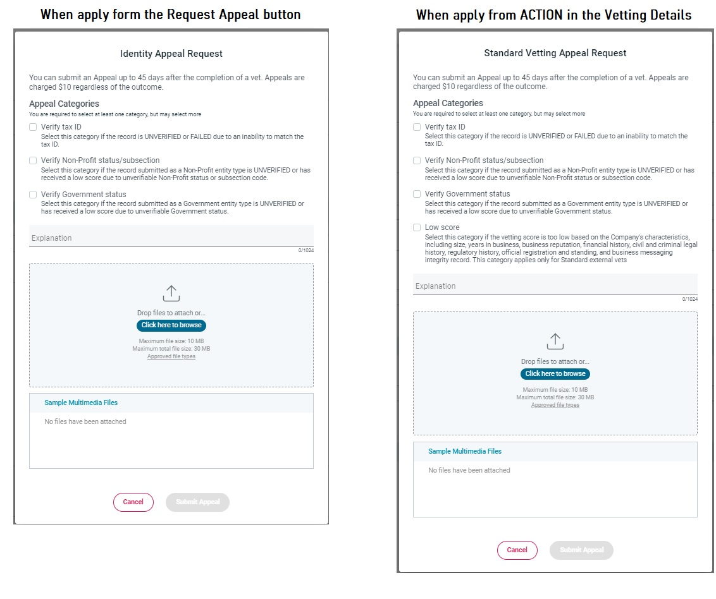

Identity appeal request form have 3 section

1. **Appeal categories (at least 1 is mandatory)**
   * + **Verify tax ID-** If the brand is UNVERIFIED identity status or failed standard vetting because the TAX Id not matched.
     + **Verify NON- profit /subscription-** If NON profit entity type was UNVERIFIED or received low score because of the nonprofit status or subsection code not be verified
     + **Verified Government status-** If Government entity type was UNVERIFIED or received low score because of Government status.
     + **Low Score-** If CSP or Brand believes the vetting score is too low based on the brand characteristics, including size, year in business, reputation, financial history, civil, criminal legal history, regulation, official regulation & standard, and business messaging integrity record
2. **Explanation text section:** Text field where customer can do explanation about brand or reason of apply for appeal. The character max limit is 1024
3. **Upload files:** Upload document related to the brand

**WORK FLOW**

1. **When Appeal from “Request appeal button”.**
   * + Click on the “request appeal” button



* + - Then Identity Appeal request popup will open with from. Fill and submit.

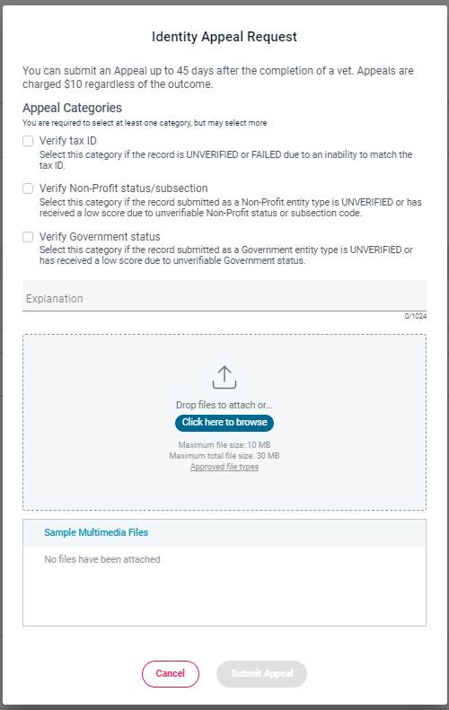

* + - Appeal Request Confirmation popup will appear to confirm Appeal. Click on the Confirm Appeal button then Successful message display.

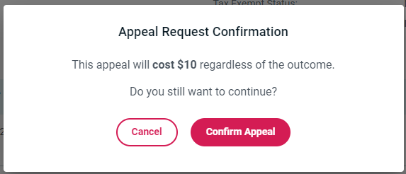

* + - After successful apply, appeal will display in the Appeal history table with column name Vetting Status, Request date, Status Update Date & details (View Details link)

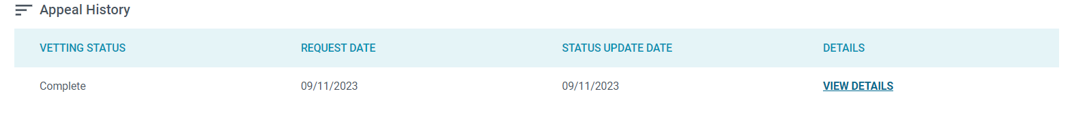

* + - When click on the View details link then check the Identity Appeal Request

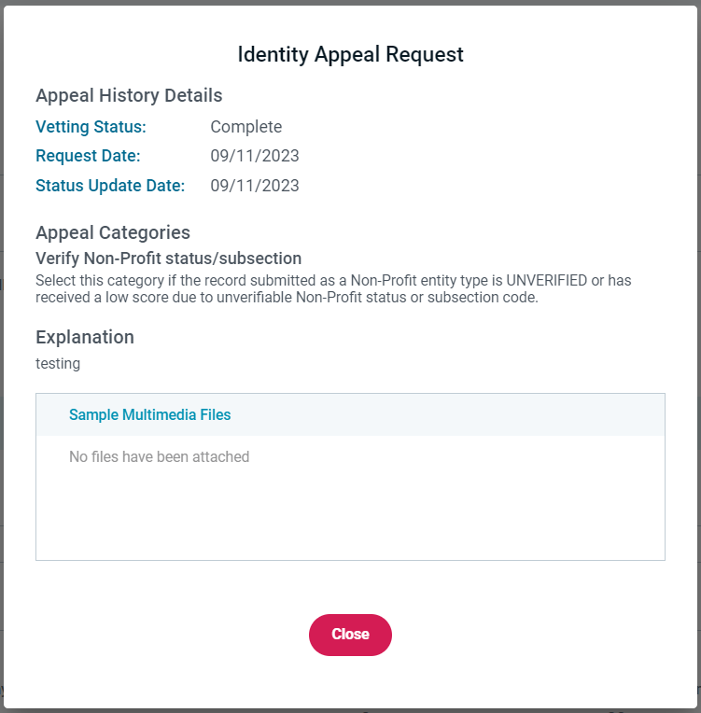

1. **When Appeal from “Action” in the Vetting details.**

* Click on the 3 dots on the Action of the vetting details then on Appeal.



* Then Identity Appeal request popup will open with from. Fill and submit. In this form a new categories is added which is LOW SCORE.

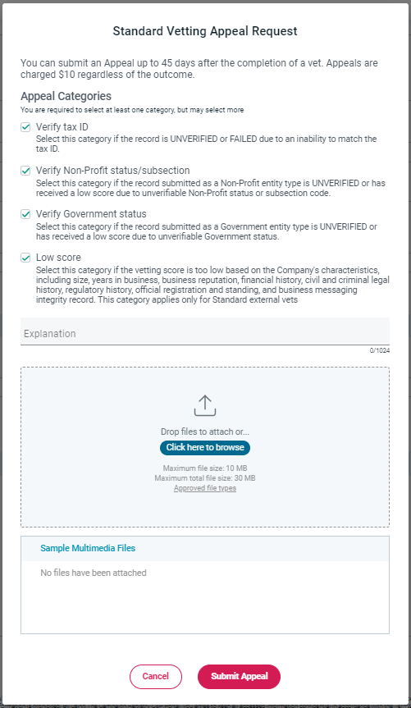

* Appeal Request Confirmation popup will appear to confirm Appeal. Click on the Confirm Appeal button then Successful message display.

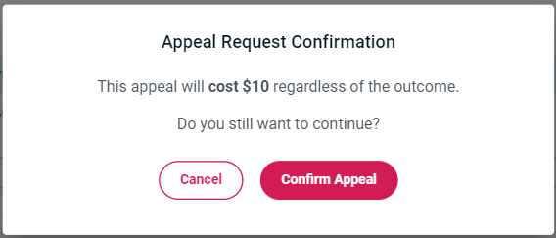

* After successful apply of appeal the “View Appeal History” button will enable, click on this and check Standard Appeal Request