**Toll-Free SMS - using INTQ**

* **Customer Side**
* Enable SMS Process

1. All toll-free numbers (Purchased from Signalmash Portal or Imported) will be displayed in the Manage Number of Customer panel. When the customer clicks on the Manage Number module then Manage Number page will open with all Numbers.

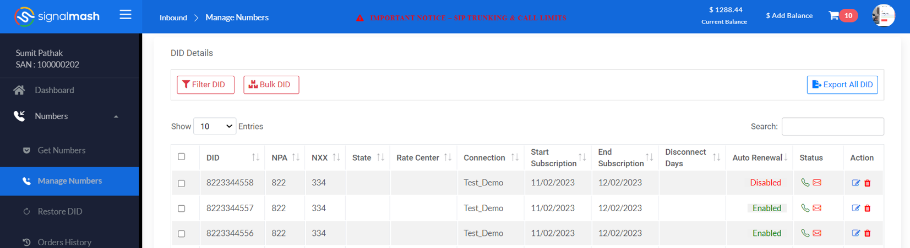

1. In the Status column, the Enable SMS icon is available. Through which Customers can enable SMS service.

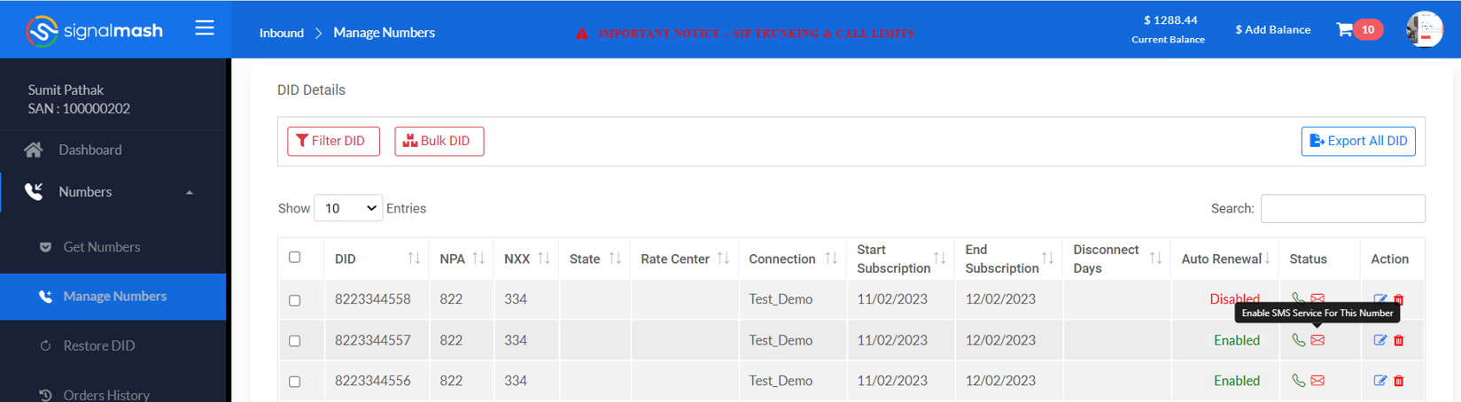

1. When the customer clicks on this icon then API **(POST / tfFeatureOrder )** will run. After geting response, sinch_status → 15 will update on the Toll free number, And on the tooltip of the Enable SMS icon for the tollfree will be “**Tollfree Number are in sender verification process**”.

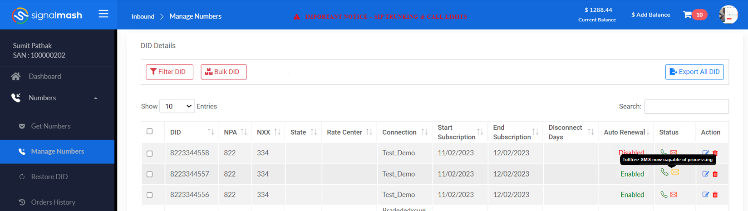

1. Customers click on the “**Toll-Free SMS**” module then Toll-free SMS page will open which contains the “**Verified sender**” button & Verified sender request details table. The table contains Request ID, Business Name, Customer Name, Date, Status, and Action (View details & Edit button).

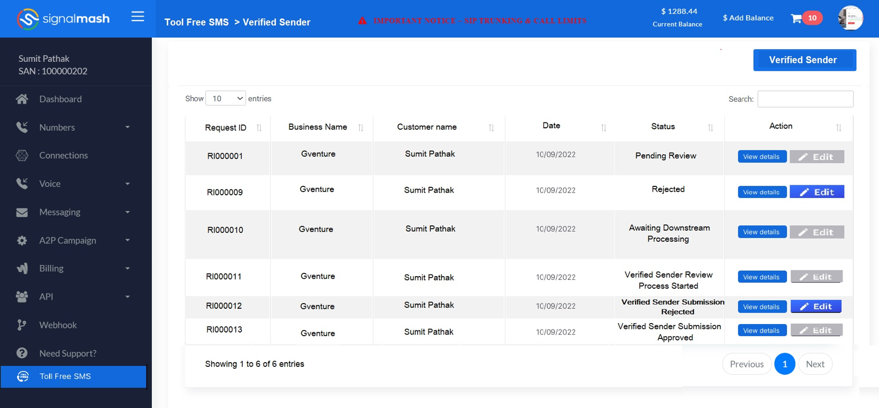

1. When the customer clicks on the Verified Sender button the form opens.

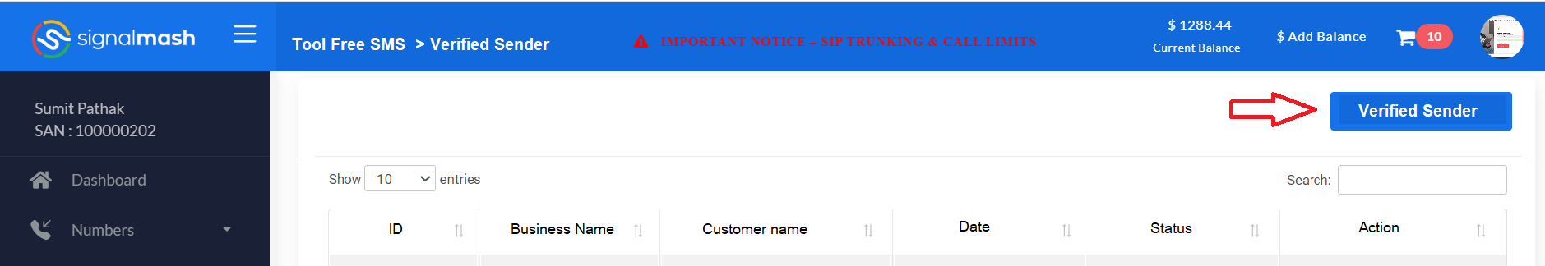

Click on Button

**Verified Sender Form Details:** The form contains all fields mentioned in the doc & CSV file. Filed which is not common from Doc should be added to the form.

All fields mentioned in the doc should be mandatory and the rest field which is from CSV should be optional.

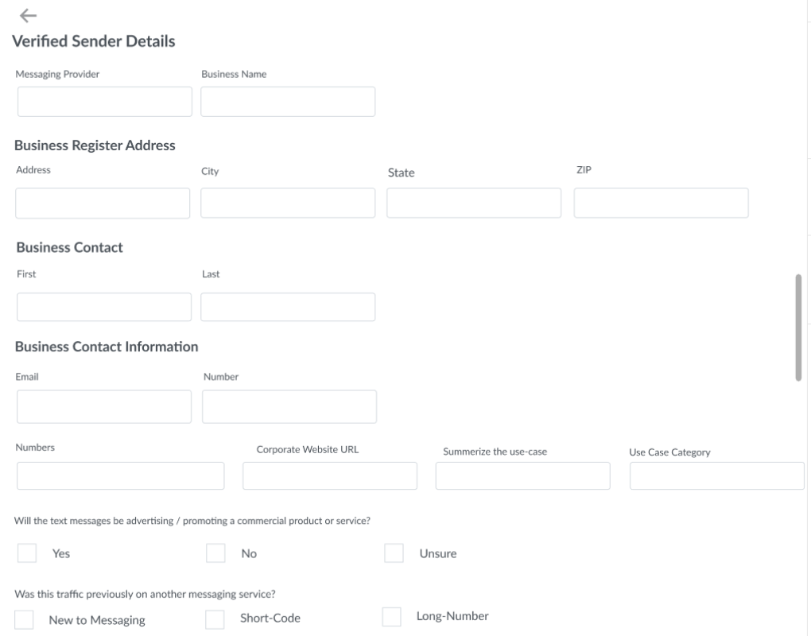

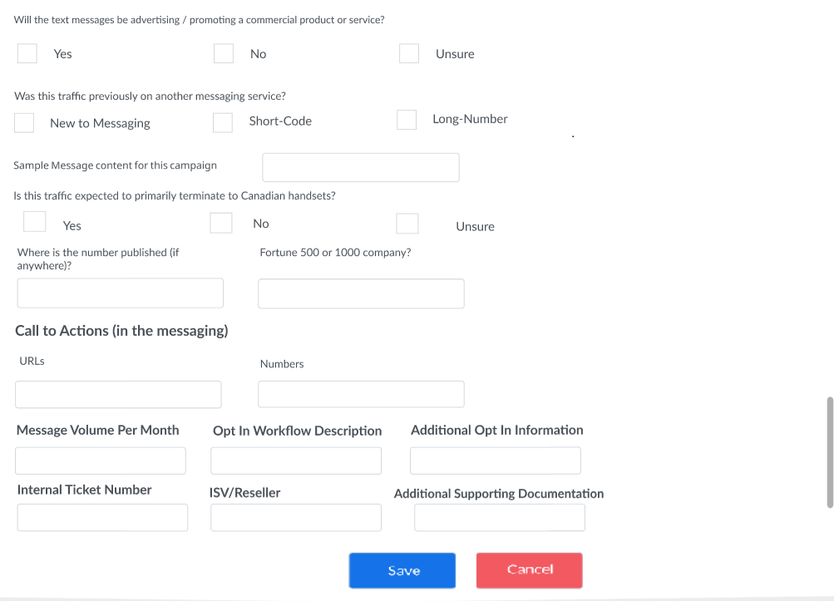

1. Customers fill out the form and select multiple numbers from the numbers drop-down & submit button from the bottom.

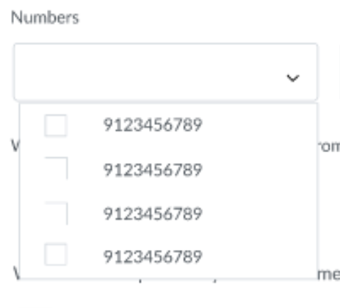 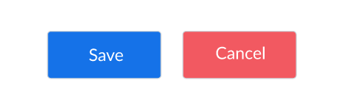

Number drop down Save & cancel button

1. After submitting the form, a new request record is added to the table with a unique ID and the status is “Pending Review”

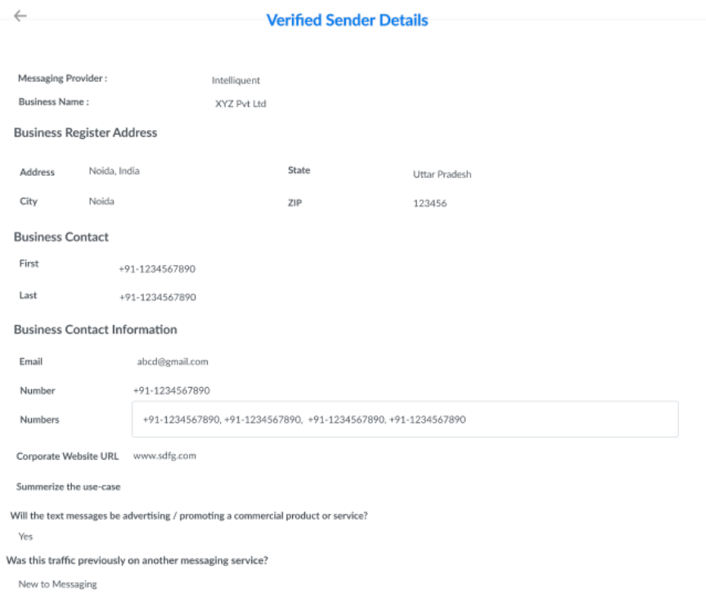

1. There is six status of every request made by the customer.

* Pending Review (Edit button Disable)
* Rejected (Edit button Enable)
* Awaiting Downstream Processing (Edit button Disable)
* Verified Sender Review Process Started (Edit button Disable)
* Verified Sender Submission Rejected (Edit button Enable)
* Verified Sender Submission Approved (Edit button Disable)

1. Customers can only view details of the form filled. And only edit when Admin rejects Verified Sender (Status:- Rejected) request or update reject status after rejected by INTQ (Status:- Verified Sender Submission Rejected)

* Disable SMS Process

1. In the Status column, the Disable SMS icon is available. Through which Customers can enable SMS service.
2. When the customer clicks on this icon then API **(DELETE / tfFeatureOrder )** will run. After getting a response, sinch_status → 0 will update on the Toll free number, And on the tooltip of the Enable SMS icon for the tollfree will be “**Enable SMS Service for this Number**”

* Send SMS Process

1. Whenever a customer sends an SMS then API **(POST /publishMessages)** will run. After getting the response data will be saved in the MDR table.**ee SMS now capable of processing**

* **Admin Side**

1. On the admin side, there is a Toll-Free SMS module. When Admin clicks on the module the Toll-Free SMS page will open. This page contains multiple tabs that represent different - different statuses. Status are:
2. Pending Review
3. Rejected
4. Awaiting Downstream Processing
5. Verified Sender Review Process Started
6. Verified Sender Submission Rejected
7. Verified Sender Submission Approved
8. Email Sent to INTQ

2. By default Pending Review section is open when the Admin clicks on the Toll-Free SMS module.

1. **Pending Review**
2. When the Customers Submit the “**Verified sender**”form then all requests will display in the table of the Pending Review section.
3. Table column name: Request ID (Unique ID of Every request), SAN, Customer name, Date, Status( Pending Review), Action(View Details)

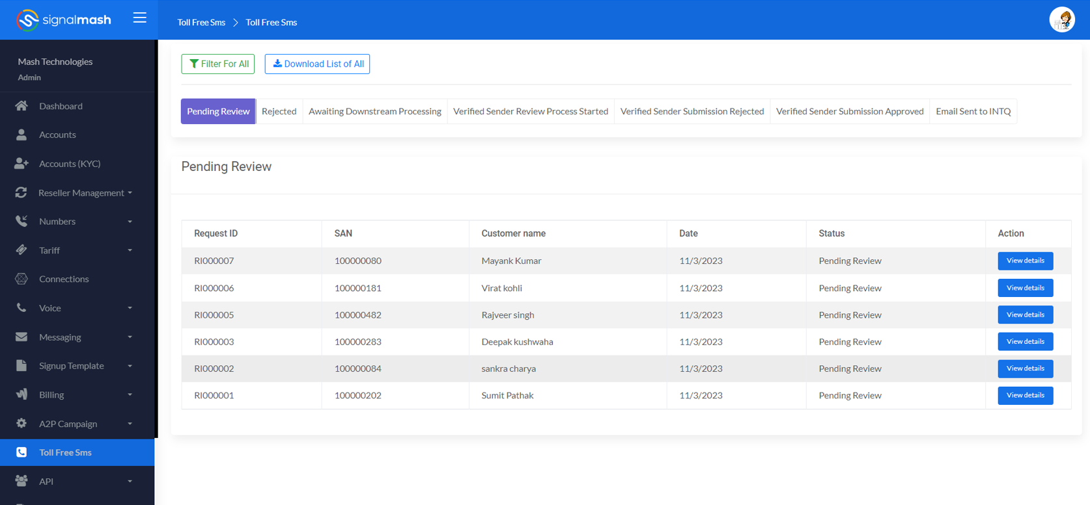

1. Admin reviews every request by clicking on the view details button from the Action column.
2. After reviewing the form in detail admin can Reject Or Approve using the button available at the bottom of the page.





1. If Admin rejects then the Customer request moves to the Rejected section
2. If Admin approves then the Customer request moves to the Approve section
3. **Rejected**
4. In this section, all request which is rejected by the Admin will be displayed in the table.
5. Table column name: Request ID (Unique ID of Every request), SAN, Customer name, Date, Status(Rejected), Action(View Details)

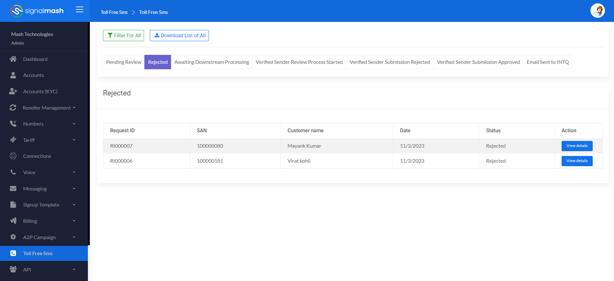

1. As the request moves to the Rejected section, the Edit request option(Edit button) is enabled on the Customer side.
2. Admin checks the details, if required by clicking on the view details button in the action column, this time Approve & Reject button is not available at the bottom of the page.
3. **Awaiting Downstream Processing**
4. In this section, all request which is approved by the Admin will be displayed in the table & a Send Mail button available at the top left corner of the page
5. Table column name: Select all check box, Request ID (Unique ID of Every request), SAN, Customer name, Date, Status(Awaiting Downstream Processing), Action(View Details)

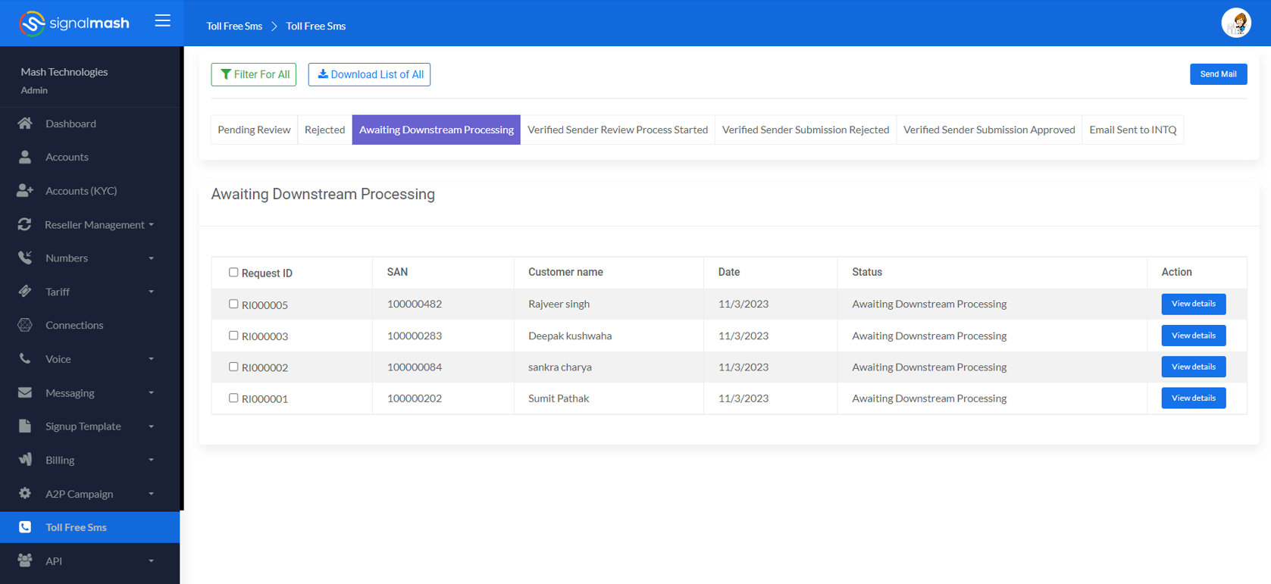

1. At the start of all approved requests have a check box. Use to select multiple requests.
2. Admin can select multiple requests and click on the send mail button.
3. A mail is sent to INTQ with a CSV file that has all customer requests, and combined details according to each individual customer.
4. All selected customer requests at the time of sending mail will move to the “**Verified Sender Review Process Started**”.
5. Every time, the send mail button is clicked by selecting customer request. One batch request is created in the “**Email Sent to INTQ**” section.
6. **Verified Sender Review Process Started**
7. All request which is sent to the INTQ by mail is available in the table of this section.
8. Table column name:Request ID (Unique ID of Every request), SAN, Customer name, Date, Status(In Process), Action(Approve, Reject, View Details)

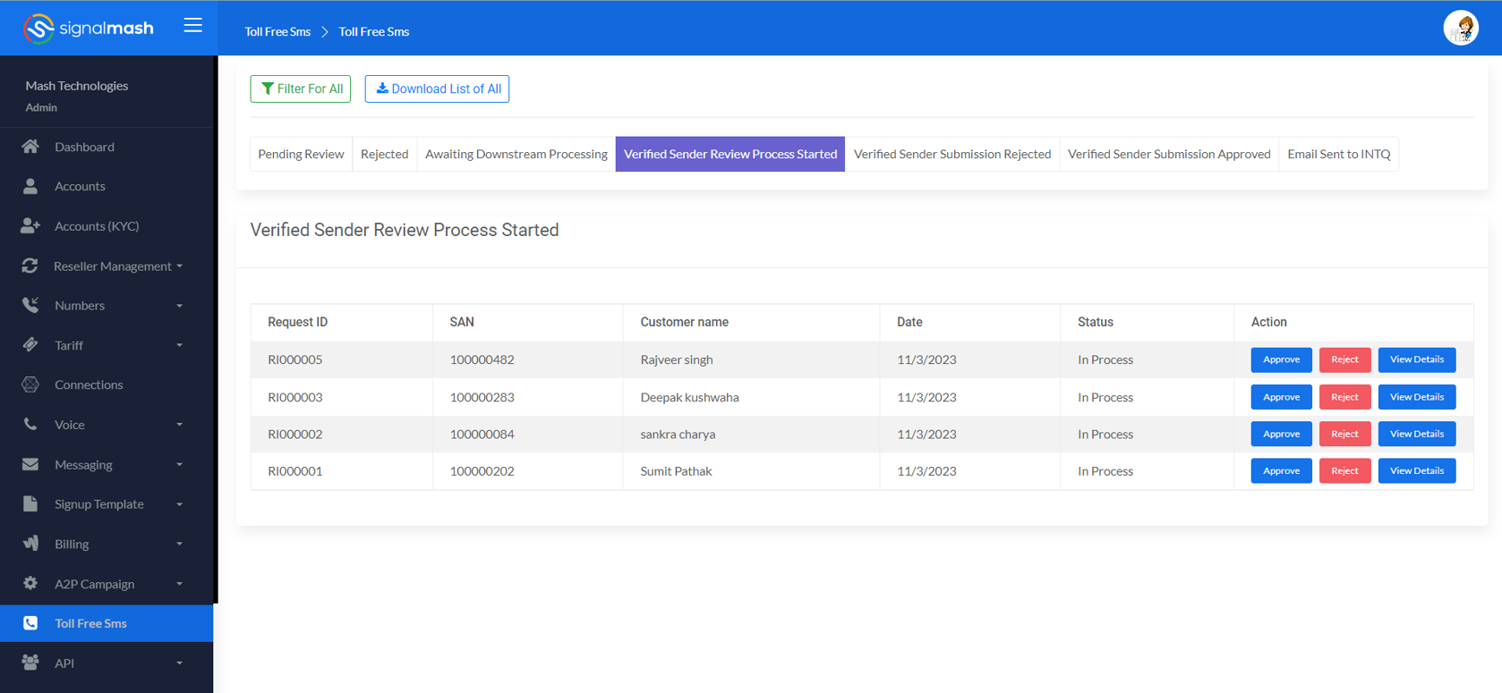

1. By clicking on the View Details Admin check the details. Save & cancel button is not available



1. If all the numbers of a particular request of a particular customer is approved by INTQ then admin approves that particular request of that customer. And that request was moved to the “**Verified Sender Submission Approved**” section.

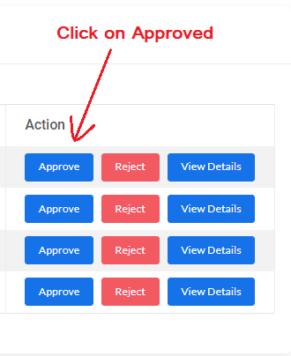

1. If any single numbers of a particular request of a particular customer is rejected by INTQ then admin rejects that particular request of that customer. And that request was moved to the “**Verified Sender Submission Rejected**” section.

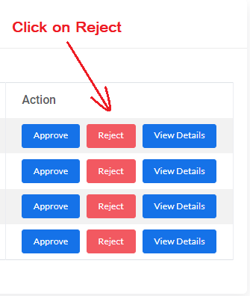

1. **Verified Sender Submission Rejected**
2. After being rejected by the Admin, the request will be displayed in the table of this section.
3. Table column name: Request ID (Unique ID of Every request), SAN, Customer name, Date, Status(Verified Sender Submission Rejected), Action(View Details & View Number).

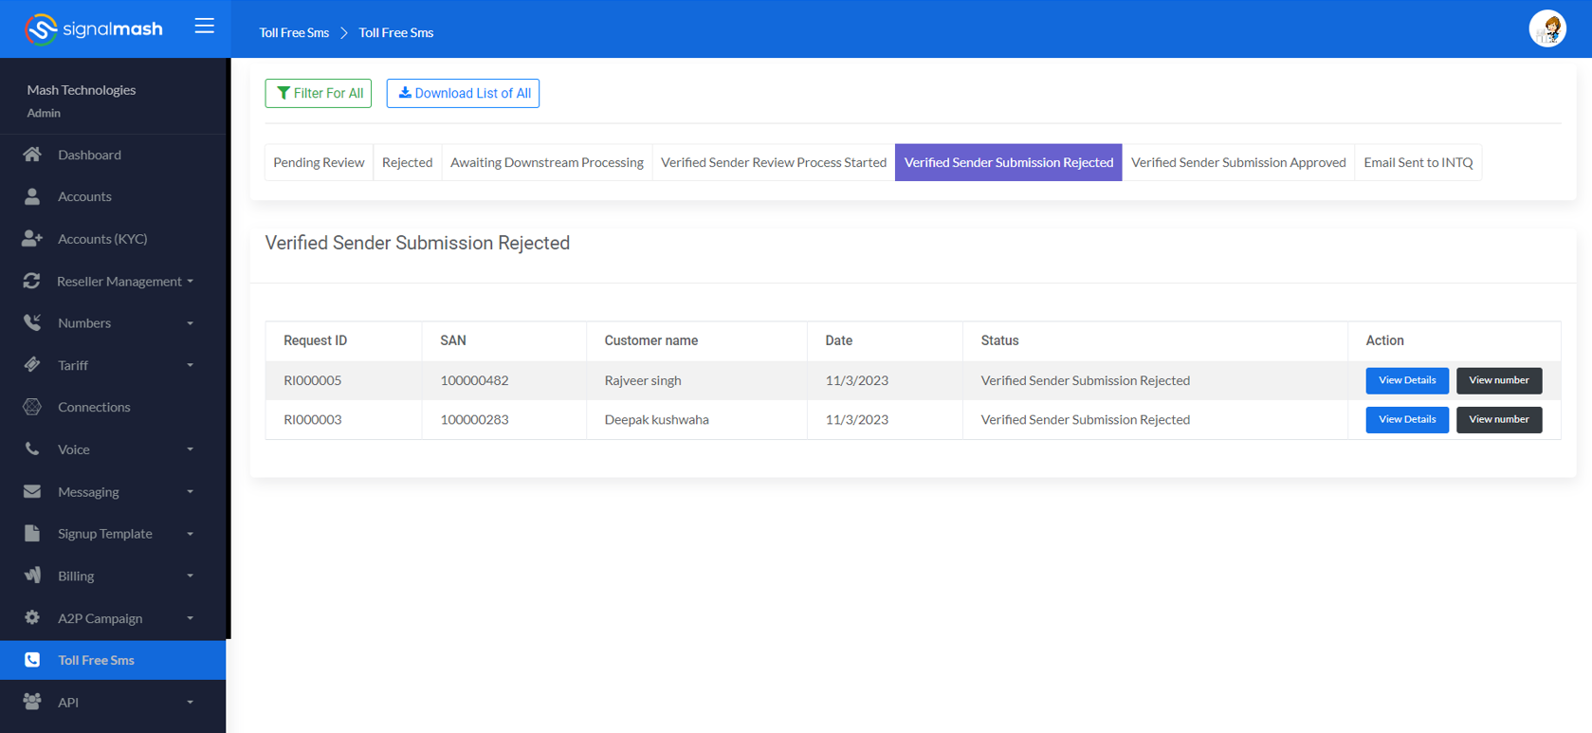

1. By clicking on the View Details Admin check the details.Save & cancel button is not available
2. When the admin clicks on the view number a popup/model will open with the numbers list which is in the request with a check box.

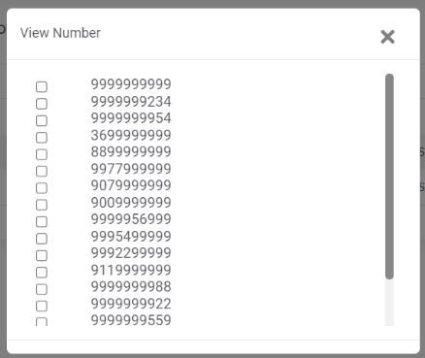

1. When the admin selects any number with a check box then the Submit & Reject button will display at the button of the popup.

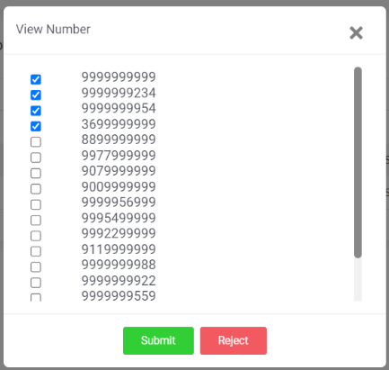

1. After selecting, if approved then the number is ready for sending SMS & **sinch_status** becomes **1**. And if rejected then it’s **sinch_status** become **15** again. Customers have to make a request again for a rejected number if required.
2. **Verified Sender Submission Approved**
3. After being Approved by the Admin, the request will be displayed in the table of this section.
4. Table column name: Request ID (Unique ID of Every request), SAN, Customer name, Date, Status(Verified Sender Submission Approved), Action(View Details & View Number).

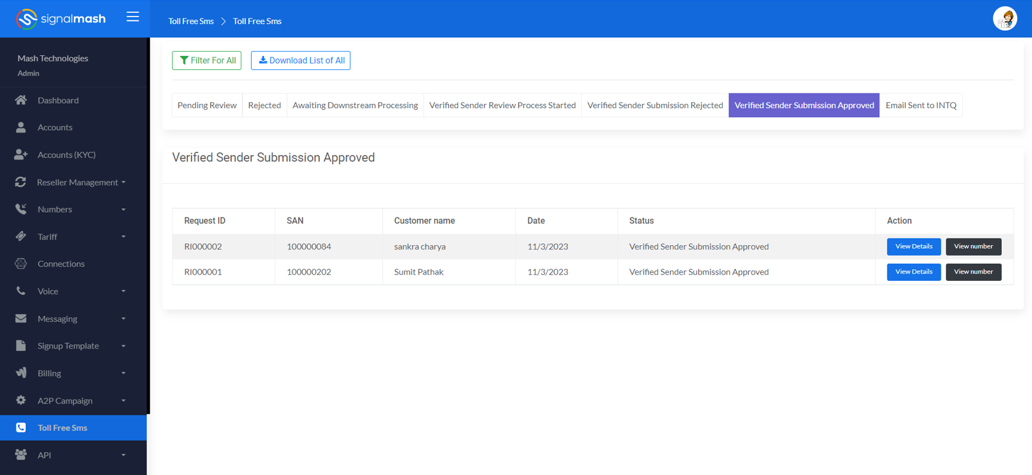

1. By clicking on the View Details Admin check the details. Save & cancel button is not available
2. When the admin clicks on the view number a popup will open with the numbers list which is in the request with a check box.



1. When the admin selects any number with a check box then the Submit & Reject button will display at the button of the popup.



1. After selecting, if approved then the number is ready for sending SMS & **sinch_status** becomes **1.** And if rejected then it’s **sinch_status** become **15** again. Customers have to make a request again for a rejected number if required.
2. If admin rejects any number from the list then the whole request will move to the **“Verified Sender Submission Rejected”** section.
3. **Email Sent to INTQ**
4. After every mail new batch will be created with a unique Batch ID and displayed in a table.
5. Table column name: Batch ID, Date, Action(View, Download, Resend Email).

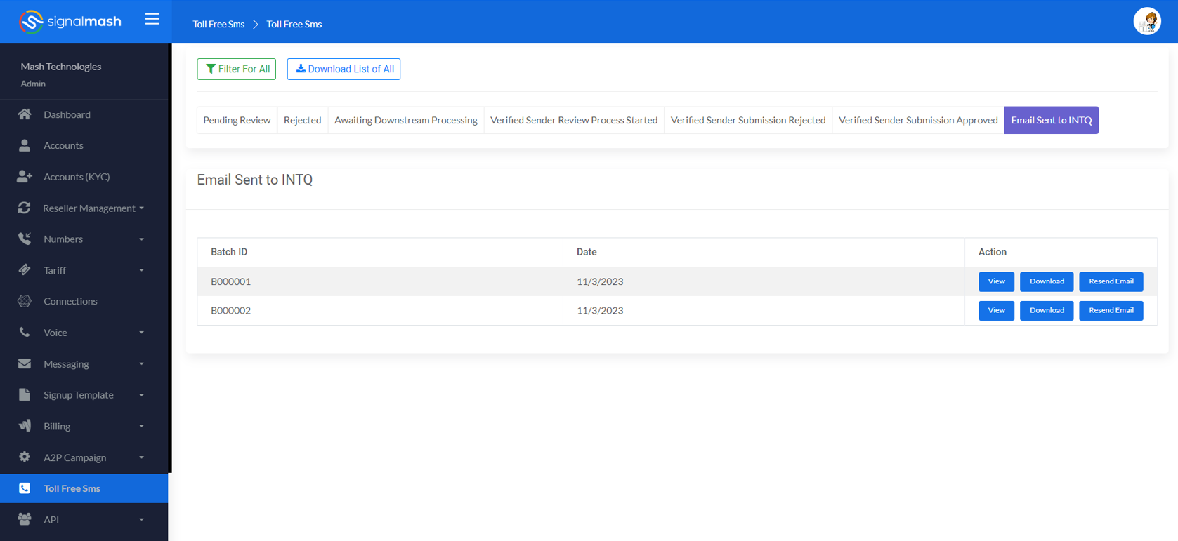

1. When the admin clicks on the view the list of all requests in that batch will display on the page. With details, Column name: Request ID (Unique ID of Every request), SAN, Customer name, Date, Status(Verified Sender Submission Rejected/ Verified Sender Submission Approved), Action(View Details & View Number).

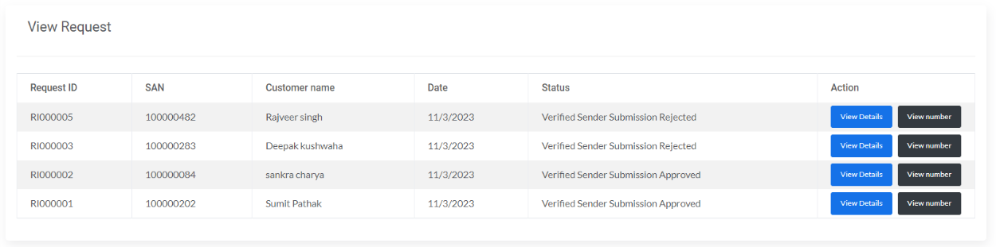

1. By clicking on the View Details admin can check the details & By clicking on the View Number admin can check the list of numbers with their current status(Approved, Rejected, Pending)
2. If all numbers are Approved.

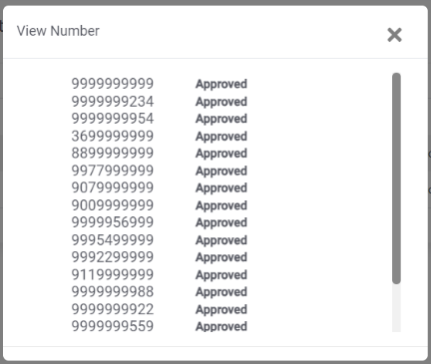

1. If an Email is sent to INTQ & waiting for a response

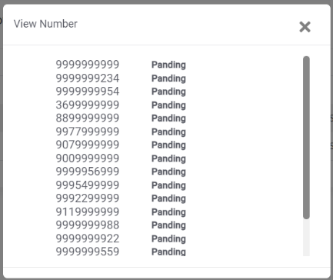

1. If few numbers are approved & few are rejected

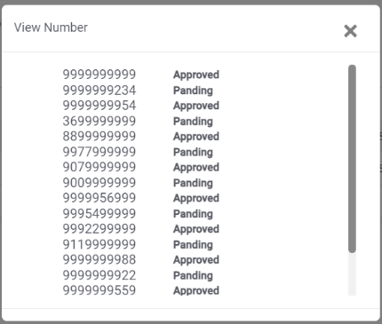

1. When the admin clicks on the download the CSV file will download with all request details which is sent to the INTQ.
2. If by any chance the Email does not get sent/ failed then by using the “**Resend Email**” button admin can again send the email to INTQ